Panama Canal Cruise – October-November 2021
We have cruised with several companies, but this was our first with Celebrity – the Millennium. Because of covid, the ship is operating at about half-capacity (we don’t know the actual number of guests or the ratio of crew members to guests), but there is plenty of wide-open space that is not the norm for all previous cruises. Social distancing is encouraged, and the Celebrity management has clearly taken every possible precaution, including vaccination of all crew members and the requirement for vaccinations and pre-cruise testing for all passengers. (Check out our San Diego posting about the issue of obtaining last-minute covid tests). The staff all wore masks at all times, and the dining room had empty tables between those that were occupied (for example, if there are 3 tables, the first and third are used for guests at only the early seating, and the middle table is used for only the late seating).
From the moment we boarded, we began noticing small touches that we have not observed on other cruise lines. For example, at the first dinner, our waiter (Alfredo) asked if we wanted slow or fast service, and he adhered to our request throughout the cruise. He and his assistant (Bainul) also asked how we wished to be addressed – Mr. and Mrs. Dann, or by our first names. From then one we were Mr. Bob and Mrs. Rosemary – a friendly touch but not one we had seen before. At the second dinner Bainul said he was going to make a napkin crocodile for Rosemary. He diligently folded and twisted the napkin, which ended up as a rose in an empty wine glass. They also had other duties during the day, and they greeted us by name wherever we met them. One night I ordered seafood bisque, and Alfredo mentioned that it might be too salty. When I tasted my first spoonful, he came over right away to verify that it was, indeed, not too salty for my taste. As a rule, most dishes were under-salted, indicating Celebrity’s awareness that the average age of the passengers was about 70, so too much salt is a common health issue. Another thing that surprised us occurred when we ordered our second bottle of wine. We had purchased a 5-bottle “Classic” package, good wines but less expensive than the “Premium” package. The sommelier returned to our table to say they were out of the wine we had ordered, and he brought a better wine from the Premium list without even suggesting any additional charge; the same thing occurred with the third wine. As has been true on all our cruises, partially empty bottles are saved for later in the week. Our cabin attendant (Sancho) must have had ESP – every time we left the cabin, when we returned, he had cleaned, made the bed, changed the towels, left the next day’s information sheet, etc. – and always with a smile and a friendly greeting. This has been, in fact, our experience on all the cruises we have taken.
The next three images are typical dining room menus. I apologize for the quality of the first one, but that is the only one I took. The very first dinner started with an amazing wild forest soup, followed by the best prime rib we have ever had. Dessert was a molten chocolate cake, so we were hooked and the meals the rest of the week were just about as good.
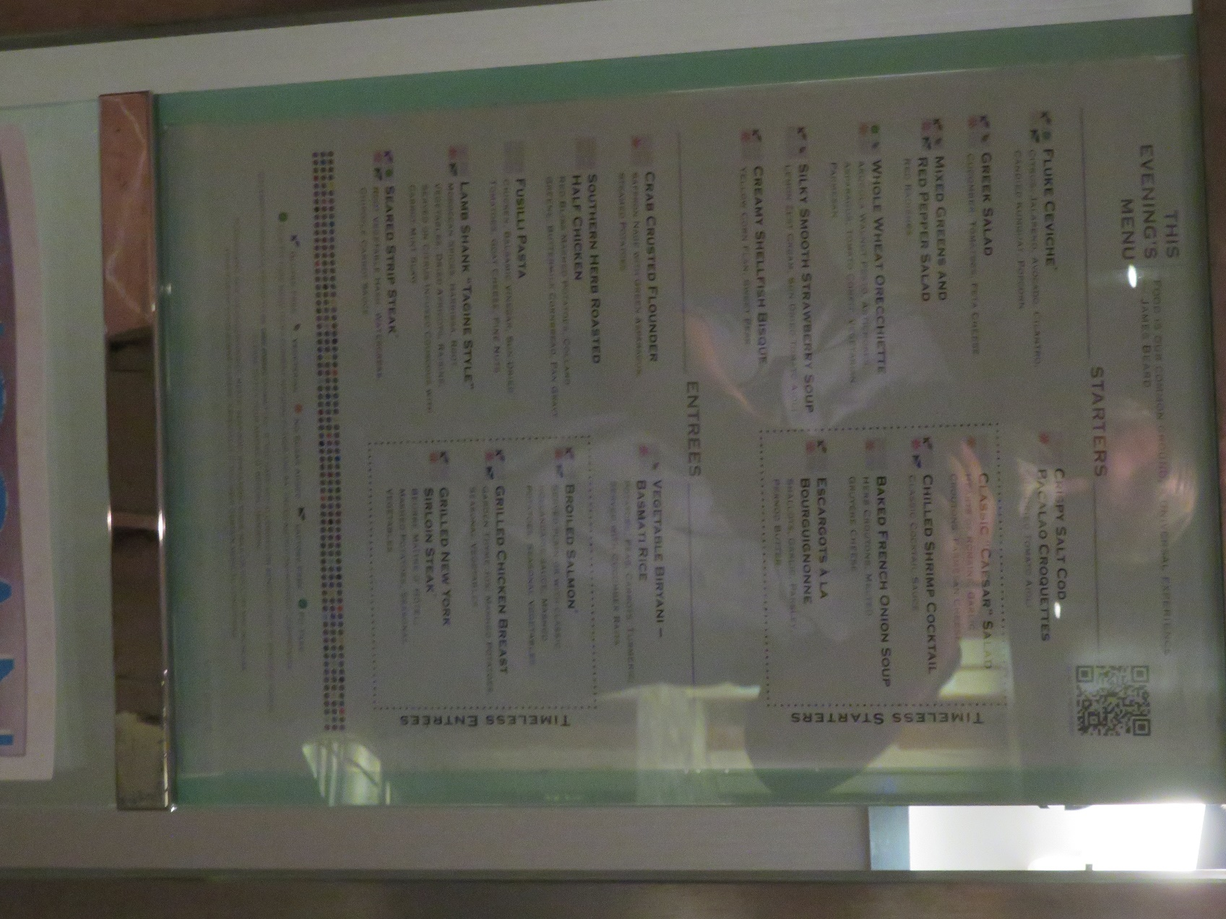
Typical Dinner Menu
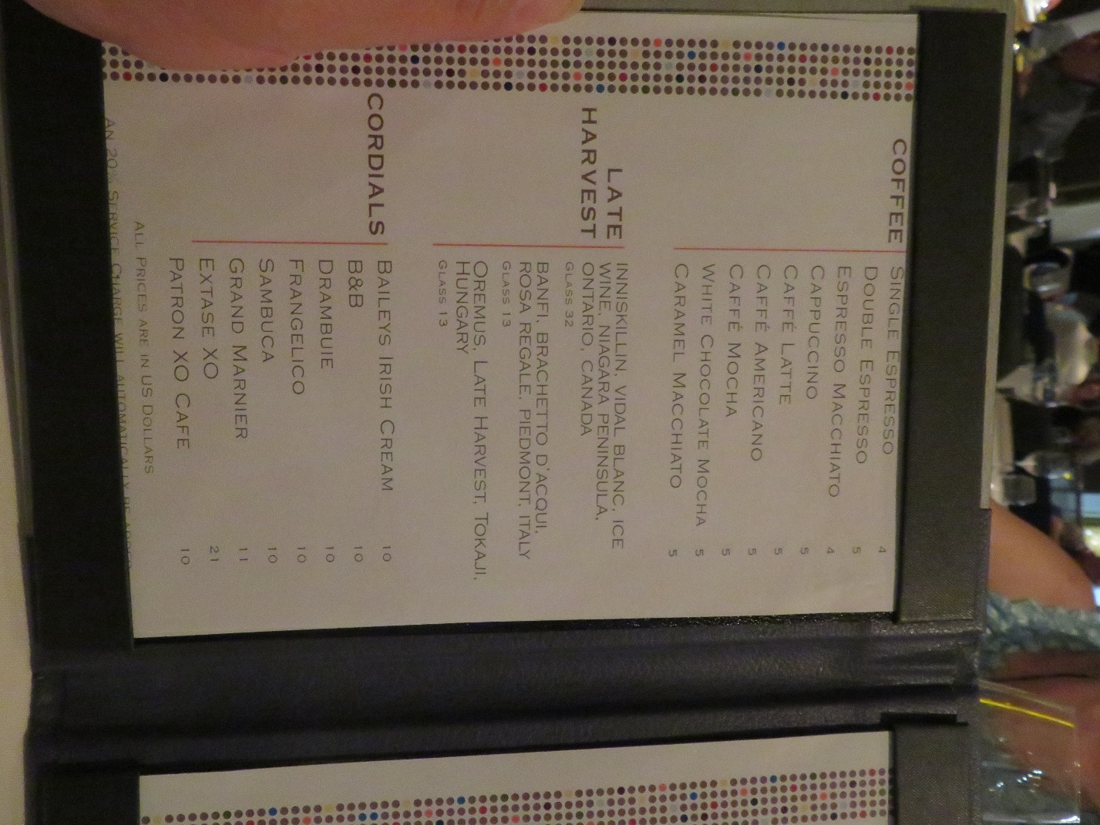
Standard Deink Menu
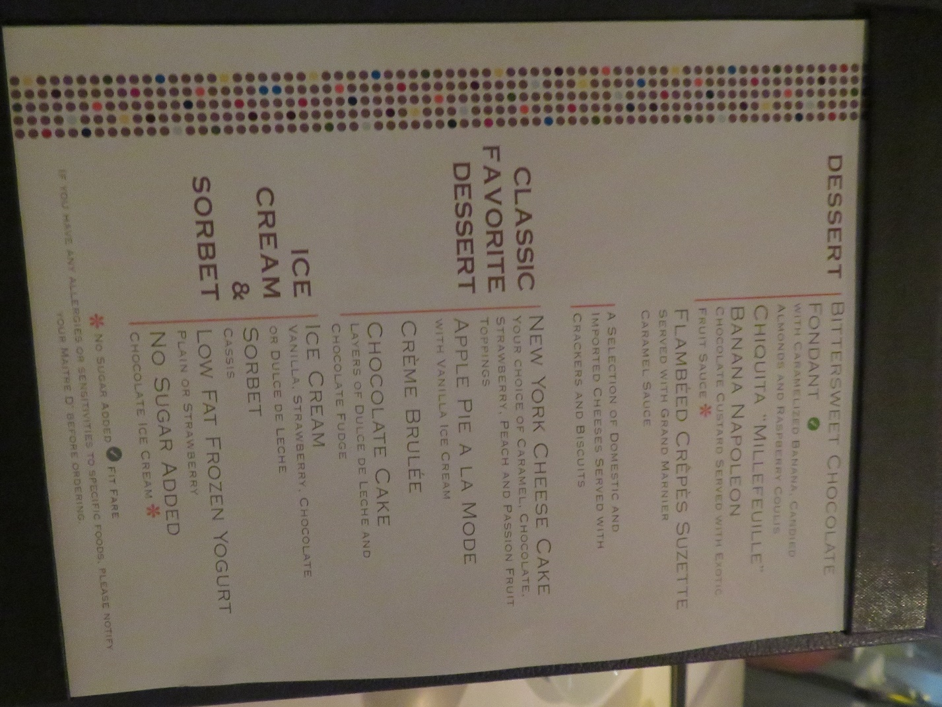
Typical Dessert Menu
As an aside, we learned from Bainul that there are hospitality training centers, at least in the Philippines, Indonesia, and India, as much of the cruise and hotel industry is staffed by people trained in these locations. On every ship, certainly including the Millennium, they are almost invariably friendly, efficient, and knowledgeable about their jobs. This really does add to the pleasure of the on-board experience, especially if you take the time, as we do, to chat with them about their home countries and families.
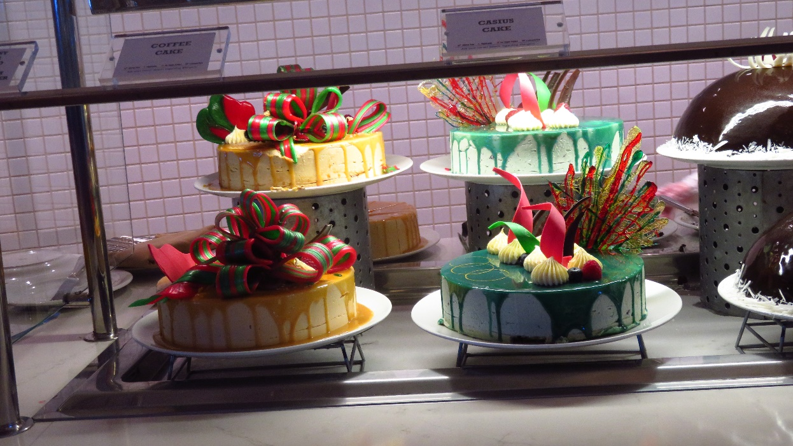
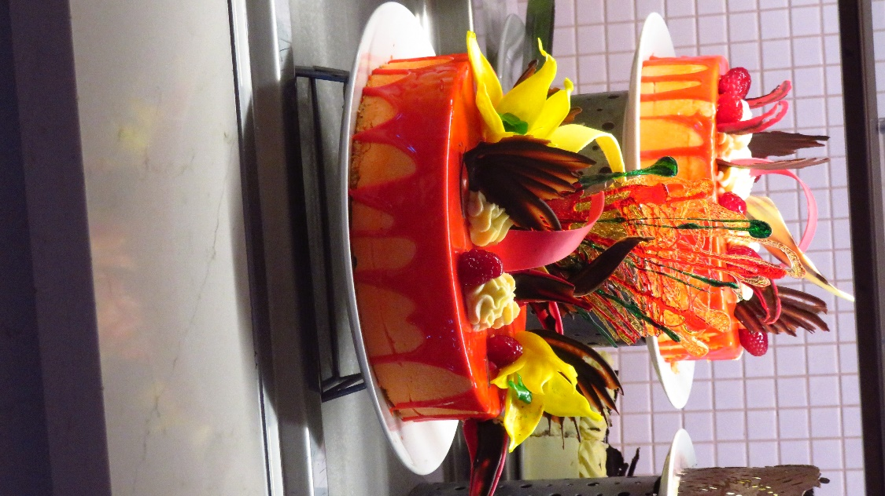
Typical Buffet Desserts
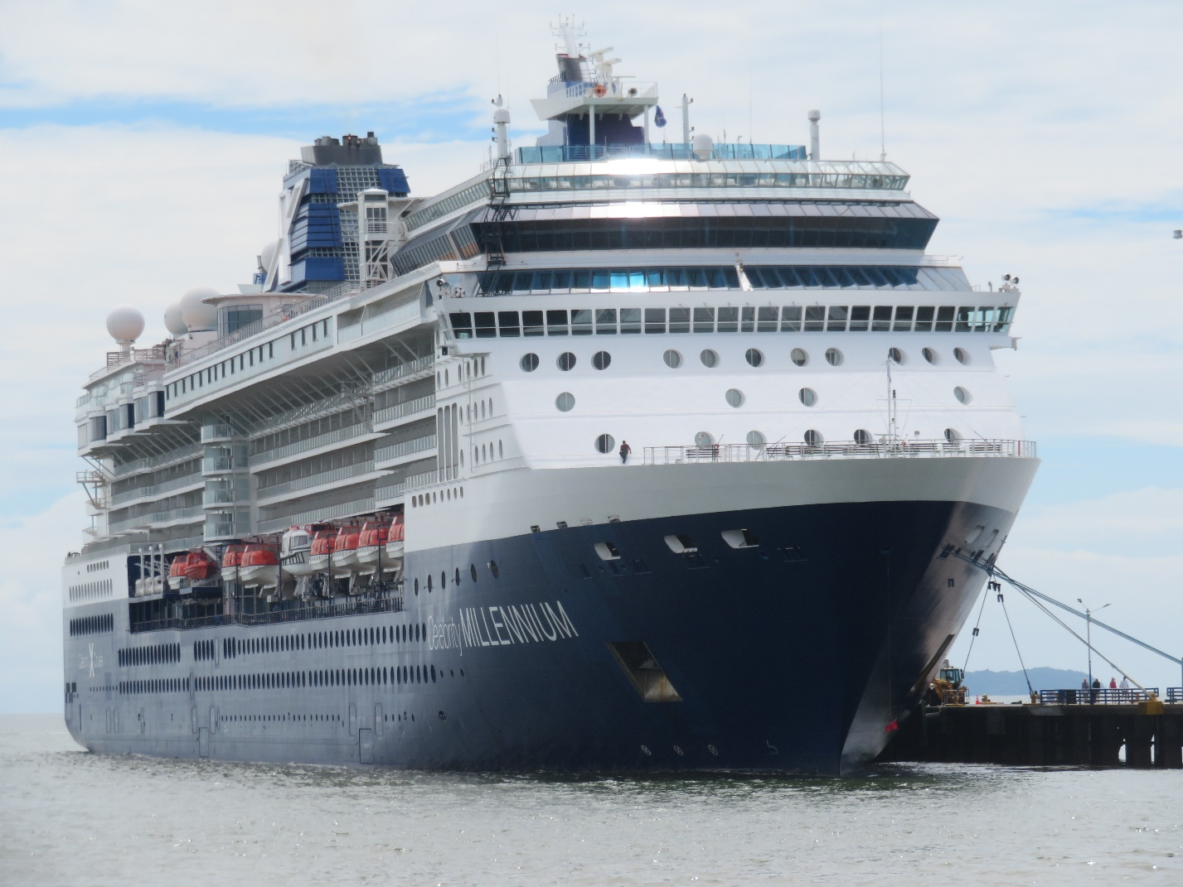
Celebrity Millennium
There are two main reasons for cruising – one is the on-board experience and the other is the places that one visits. We have been on cruises with Carnival, Chandras, Galapagos Legend, Holland-America, Norwegian, Princess, and Royal Caribbean. For most of these the itinerary was our primary reason for selecting the cruise. This was our first time on a Celebrity ship, and we chose this cruise for both the itinerary and the expected on-board experience. The itinerary is as follows: Day 1 – depart from San Diego; Days 2 and 3 – at sea; Day 4 – Cabo San Lucas, Mexico; Day 5 – Puerto Vallarta, Mexico; Days 6 and 7 – at sea; Day 8 – Puerto Quetzal, Guatemala; Day 9 – at sea; Day 10 -Puntarenas, Costa Rica; Day 11-cross the Panama Canal; Day 12 – Colon, Panama; Day 13 – Cartagena, Colombia; Days 14 and 15 – at sea; Day 16 – arrive in Ft. Lauderdale, Florida. There will be separate posts for each stop.
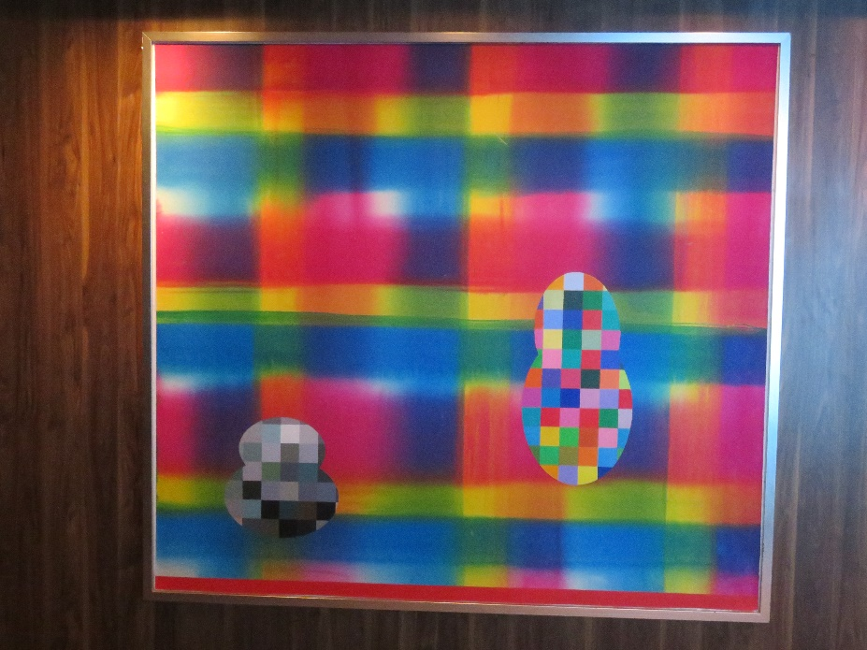
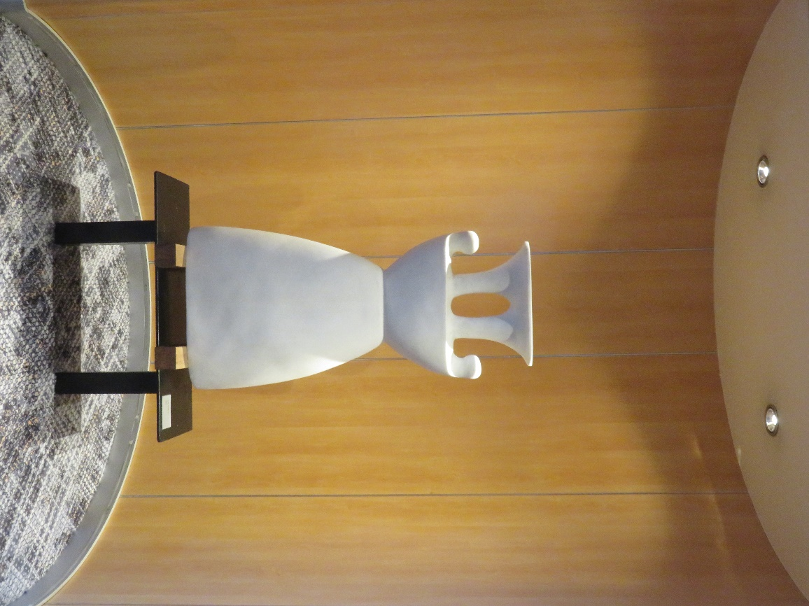
Two of Many Art Works Around the Ship

A bit about the Art Gallery. All the major cruise lines have them on their ships. Park West is the largest art dealer in the world, having a brick-and-mortar home gallery/museum in Southfield, Michigan, as well as its presence on the seas. We have purchased artworks from them on several occasions. The auctions are fun, even if you don’t buy anything, with prize giveaways (I won a bottle of champagne) and clever patter, and they educate you about the art and artists they represent. Don’t be surprised if some of the attendees have no problem bidding over $10,000 or more on certain works (like Peter Max and Picasso). They’re way out of our league! But, as I said, it’s a fun experience if you’re into art. And, in full disclosure, at the very first auction we attended, I won the grand prize – a 3x4 foot, signed and numbered, framed lithograph by Chagall.
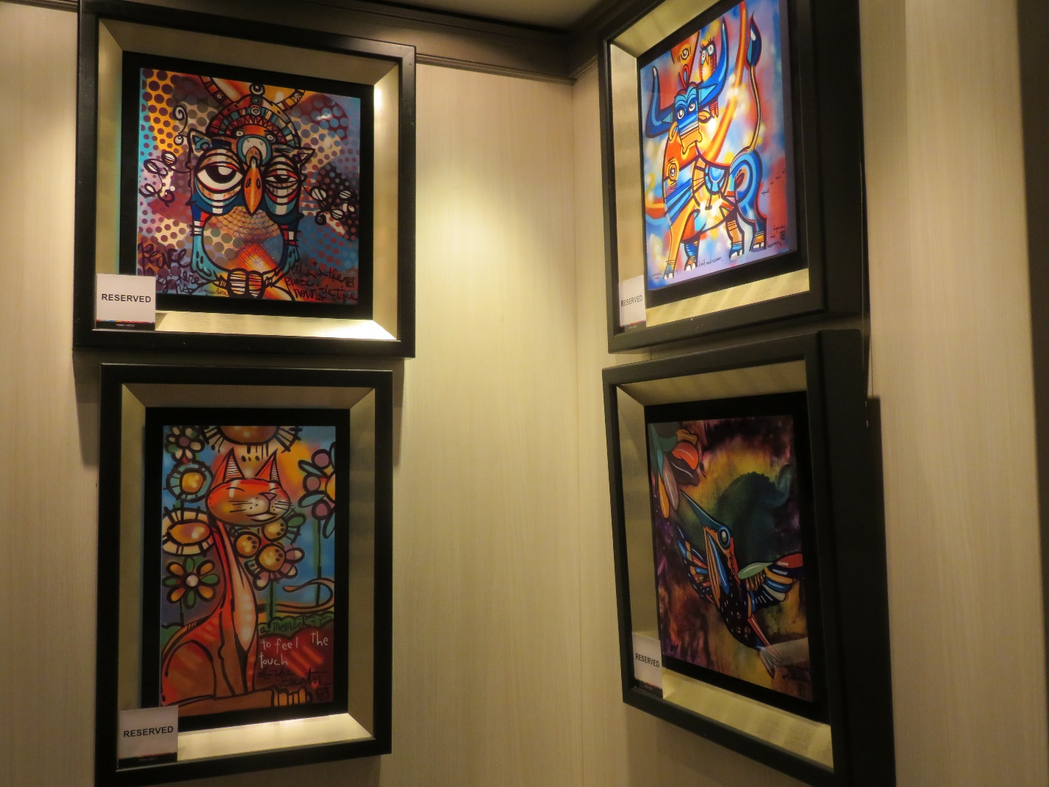
Some of the Paintings Up for Auction
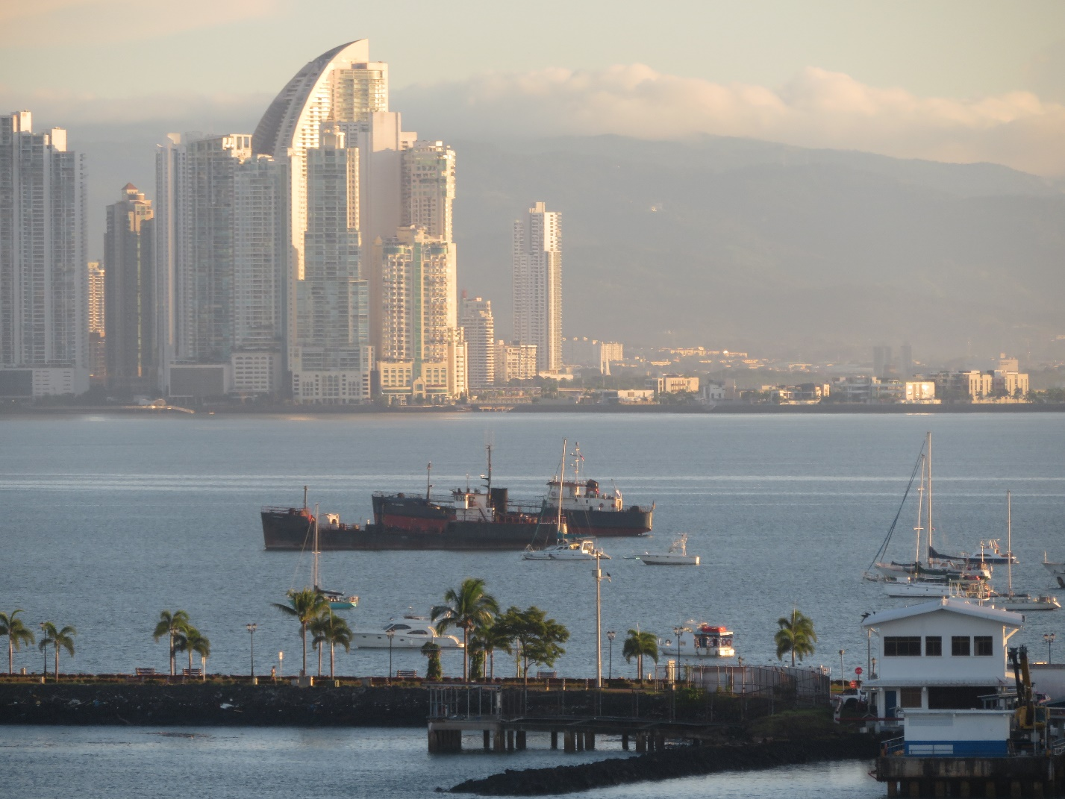
Panama City
Day 11 - Traversing the Panama Canal
The building of the Panama Canal is fraught with history. Many tried and many died in accomplishing that feat. The actual crossing takes 8-10 hours. Any ship going through the canal has to pay a fee. For cruise ships it’s based on the number of beds. My first thought was to push together the two twin beds to make one double; I’m sure I am not the first to think of that… The fee for our ship was about $450,000 dollars. Your reservation is for a certain time slot, and you have lots of company. The order of passage is determined by the size of the ship. Big ones (cruise ships and freighters) go first. The order is also determined by how much of a “surcharge” you are willing to pay for a good spot in line.
The Celebrity Millennium is considered a medium sized ship, and can still fit through the locks, but just barely. In many spots, there is less than one foot of space between the side of the ship and the lock. There is a new Canal, parallel to the original, for much larger ships. There’s an 80-foot difference between the levels of the Atlantic and Pacific Oceans. Because of Panama’s “switchback” form, the Canal runs north-south.
It’s truly an engineering marvel and was built to be very eco-conscious. The water in the upper lock is pumped into the lower lock, then vice versa for ships going in the other direction. Also, the canal generates its own electricity. Pretty cool! There are green banks of lawn and trees along the waterway, and we saw deer, coatimundi, and capybara along the way.
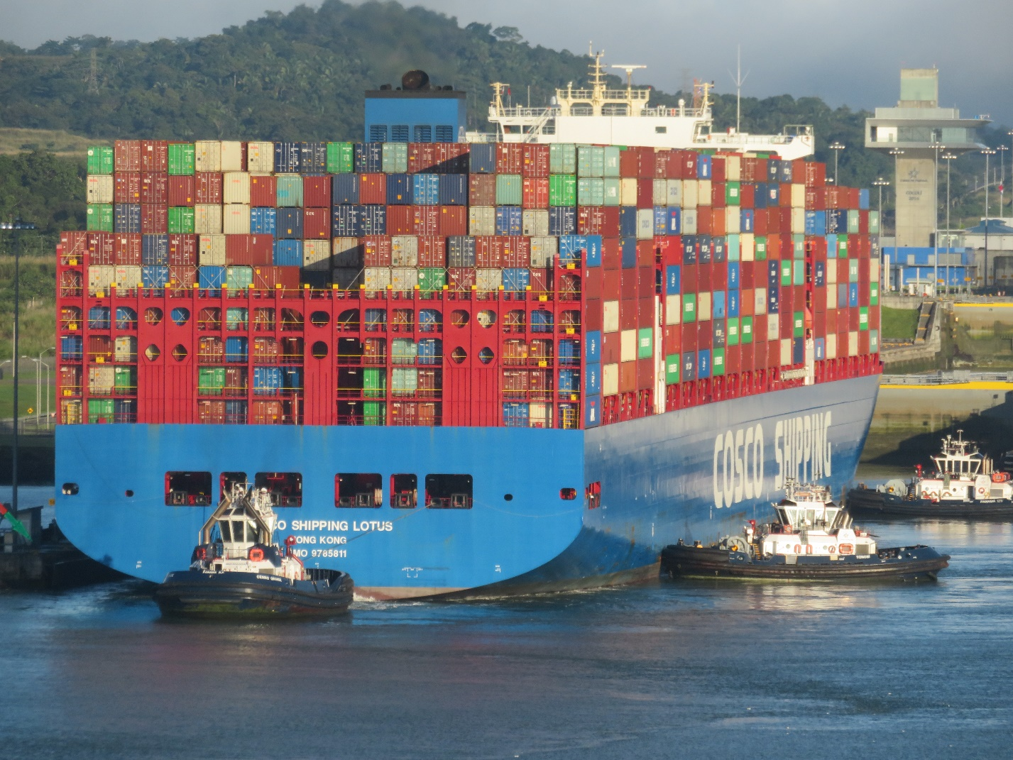
A Ship in the Lock before the Millenium
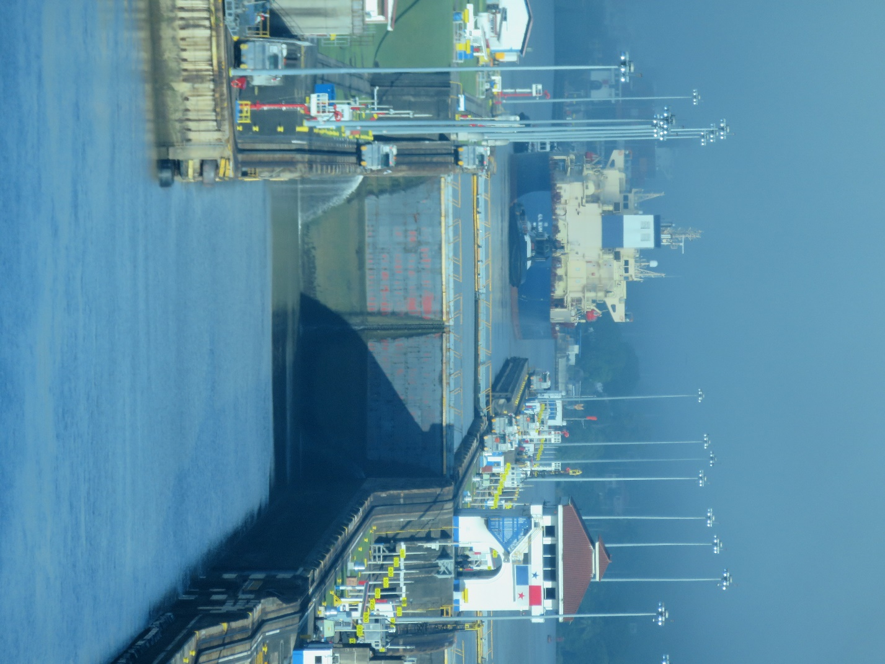
A Ship Already Through the One of the Locks

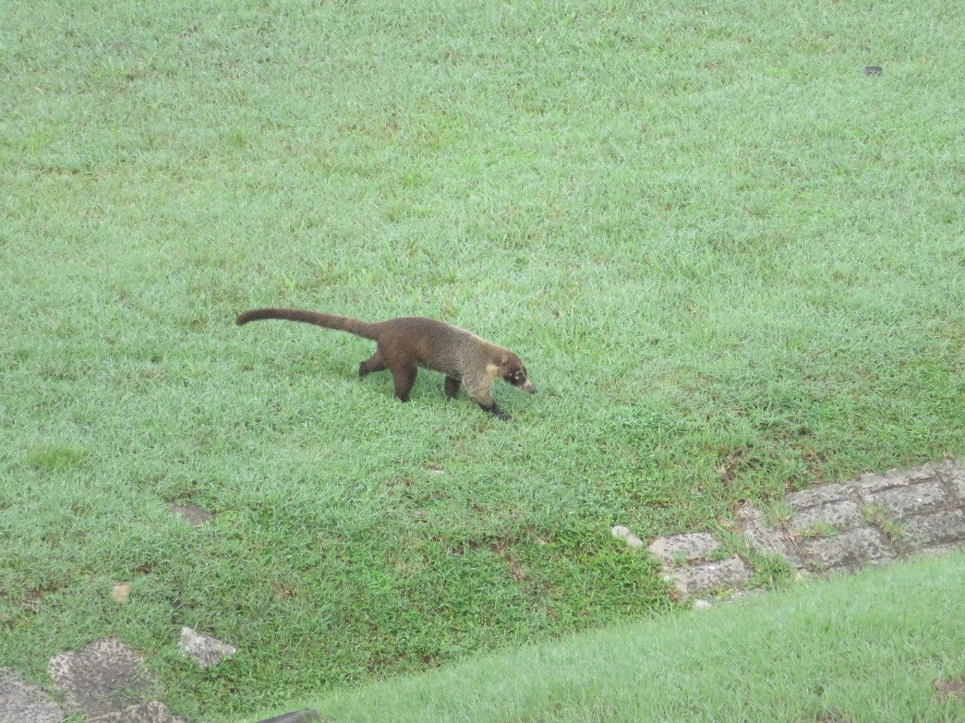


Wildlife Along the Canal – A Coatamundi and Three Deer
Day 16 - Ft. Lauderdale
From Cartagena, we had two days at sea, making our way between Cuba and Haiti, past the Bahamas, and other assorted islands before finally disembarking in Ft. Lauderdale. But that’s another story.

