Blog entry-San Diego
After several weeks of catching up with “real life” in Scottsdale, we set out for San Diego, for the beginning of a three-month jaunt. Our daughter drove us out and stayed with us for several days while we were marking time until our cruise through the Panama Canal departed. Our cruise, and I imagine every cruise now, requires a negative Covid test, done no later than two days before departure. Coming from Phoenix, where you can walk into almost any CVS or Walgreen’s and get a free test done without an appointment, we were taken aback by the unavailability of Covid testing; there was nothing available within a hundred miles of us. Reluctantly, we made an appointment with a testing lab located at the airport that charged $150 per test, because it could. The next day we received the results and could breathe easy. We were cleared for travel! (Tip: Just about all airlines and ships are now requiring negative Covid tests. If you are not able to go to your local testing site, be sure to research locations near your departure site and make a reservation, if necessary, to avoid the hefty additional expense!)
San Diego has so much to offer, it’s hard to know where to start. On our last visit there, we covered Old Town, the San Diego Zoo and Safari (two separate locations), the Japanese Garden at Balboa Park, the Cabrillo National Monument (which contains a military cemetery), the Aquarium, the Mission of San Diego de Alcala (the first mission founded in California by Father Junipero Serra), and the famous Coronado Hotel. Needless to say, after a week of non-stop activity, we were exhausted. This time around, we confined ourselves to Balboa Park.
The Park covers 1,200 acres and is the home to a variety of museums, restaurants, theaters, and other attractions. It was built as the site of the Panama-Pacific International Exposition beginning in 1910. The original buildings were designed in golden sandstone to resemble Spanish and Mexican colonial architecture with coats of arms commanding the portals and twisted baroque columns graced with grapevines guarding the doors. The Alcazar Garden is fashioned after its model in Spain, both in design and plantings. The unmistakable aroma of the boxwood hedges immediately brought me back to Sevilla.
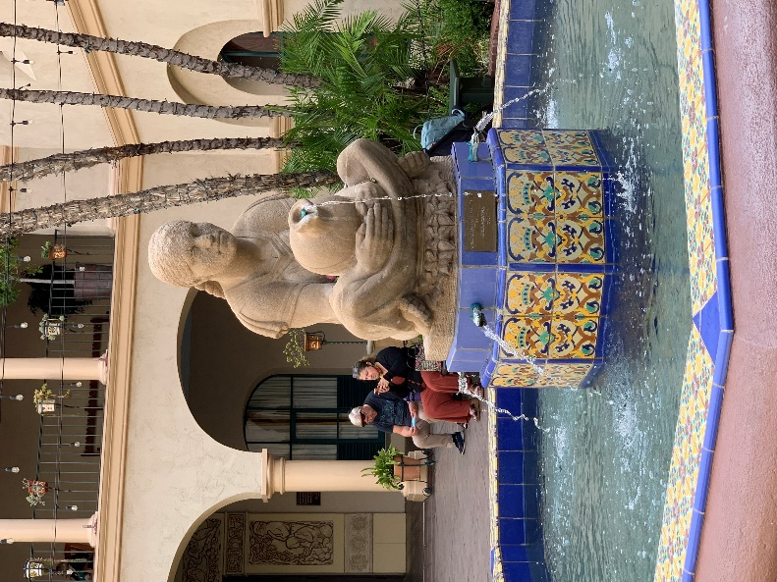
Ilana’s colleague who works at the Mexican Consulate tipped us off to a performance by several members of the San Diego Opera, that the Consulate was sponsoring at the Mingei International Museum, highlighting the Day of the Dead.
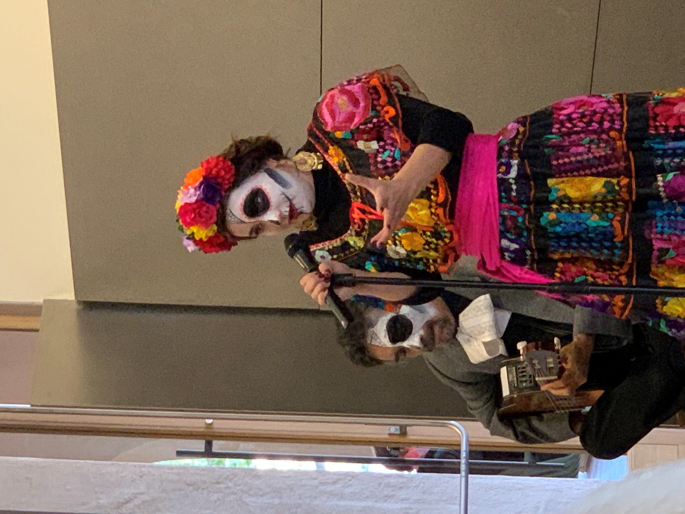
After the performance, we wandered a bit, taking in the relaxed atmosphere of fountains, gardens and children’s play areas, and came across a photoshoot for a quinceanera – a traditional party held when Hispanic girls turn 15. We had lunch at the WorldBeat Cultural Center, founded by Makeda Dred, an amazing woman of undetermined age, who, some three decades ago, convinced the City Council that the park needed a Black presence; they agreed, and she made the rest happen. The Center hosts musical and cultural events and has outreach programs, especially for children. The wonderful salad we had for lunch was composed entirely from plants and flowers grown in the Peace Garden; Makeda (another of Ilana’s friends) gave us a personal tour of the garden, pointing out different plants and flowers, and their uses. It was a small piece of Eden in an otherwise bustling city.
To round out the visit, we watched the sunset at the appropriately named Sunset Cliffs. This is a popular spot for both visitors and natives, alike, and parking can be a problem, so it’s best to come early, and bring something to sit on, because the rocks can be muddy and damp. The actual beach is at the bottom of the cliff, dotted by small coves with crashing waves and tranquil tidepools. Ilana and I made our way down to sit on a rock ledge and wait for the daily spectacle. Bob decided to stay at the top for a different camera angle and sat on a bench. He was approached by a young lady who asked if she might share the bench. She was part of a foreign study group and welcomed the opportunity to practice her English. Meanwhile, below on our rock seats, we watched a bridal photoshoot. I assume that this was post-festivities, as the hem of bride’s gown was tinted red with mud by the time they finished. Watching the sunset over the open ocean provides an opportunity to see the “green flash”, if you’re lucky. It occurs for what seems like a millisecond just as the sun finally disappears on the horizon. I have watched many sunsets, on many beaches, and have seen it just once, in Hawaii. It was worth waiting for. But, hey, I’m easily amused.
