Flagstaff, Page, Escalante, Williams, AZ – October 2021
After the Sedona trip, we returned to Scottsdale for a week and met with Rosemary’s orthopedic surgeon. He was very confidence-inspiring, and the bottom line is that we scheduled the hip replacement surgery for Jan. 20, 2022. She feels well enough to make it that long, and she did not want to miss the upcoming cruises, so that is on our calendar.
We could insert an x-ray of a hip in need of replacement, but we won’t.
On the road again, we headed north, stopping overnight in Flagstaff. Looking for inexpensive accommodations, just to break up the drive, we booked a Motel 6. It was adequate but highly overpriced because it was Parents’ Weekend at Northern Arizona University. We remember why the motel chain was originally named: you could get a decent room for $6.00 a night. Not so much anymore. Try $100. (Tip: if at all possible, check out local college calendars and sports teams for big dates and try to avoid them. Your pocketbook will thank you.)
Referring back to the pre-wedding disasters, it seems like we were destined to parallel them with pre-road trip disasters. Well, they weren’t really disasters, but the day we hopped into the car to drive to Flagstaff, this is what happened:
- The bank branch that we usually use, with an ATM, had ceased to operate, and the ATM had been removed. OK, no disaster, but it did delay us a bit.
- Road work on Pinnacle Peak Road was supposed to have been completed a week before, so we took it, only to discover that they had not been as efficient as planned, so another delay getting through the construction areas.
- We reached route 17, the highway going to Flagstaff, and almost immediately had a rock hit our windshield and start a 1-inch crack that will require repair – some more wasted time.
- Two big trucks decided route 17 would be a good place to play games with all the other traffic, so they would take turns passing one another. 65 MPH speed limit, so they were going 55 and 55.01, requiring about 10 minutes to make their pass. So, a few cars got by until they repeated the game. Another appreciable delay getting to Flagstaff.
- We got to the Motel 6 noted above, and I had to go back to the office 3 times to get a key that actually opened the door. Just a little time wasted.
- The bed was a double that, I believe, still had the original mattress from when the motel cost $6 a night. Not exactly a wonderful night’s sleep.
- Partly because of #6, I had a dream that included our car being stolen. I woke up pretty early and went outside to check on the car – it was still there, but there was a gentleman walking around saying his car had been stolen! No disaster for us, but it was for him!
- When we finally went out for breakfast (no longer included at motels like this one), there was a young lady knocking on doors because she had left her cell phone in an Uber, and there was an Uber parked in the motel lot, but obviously, she didn’t know which room the car belonged to. Again, not a disaster for us, but a reminder that this could easily happen to any of us.
Moving on, we drove through Marble Canyon and Kanab, and stopped in Page, which is a cute town, nicely laid out, and just a few minutes from several natural wonders. This entire route passes through the aptly-named Vermilion Cliffs. There also is an area of Chocolate Cliffs, again appropriate due to the color of the earth.

There are many restaurants to choose from in Page, but the pervasive aroma of barbeque led us to Big John’s Texas Barbeque, where the smoker runs non-stop, the resulting barbecue is good, and the live country music is also good. We checked out the Powell Museum, which was closed, and the Conservancy next door. John Wesley Powell led the first non-native expedition up the Colorado River, mapping it as he went. When he came to what is now known as Horseshoe Bend, he faced a dilemma; it was impossible to see what was literally around the bend: would it be calm water or rapids and waterfalls? Were their boats strong enough to withstand what was on the other side? He decided to take the risk and found calm water, allowing the expedition to proceed (A replica of his boat, the Emma Dean, is on view at the Powell Museum). Until recently, if you wanted to see the iconic geological structure, you had to park by the side of the highway and hike in about a half mile. But because of its popularity, the town of Page built a parking lot (paved) and a path (hard-packed earth) leading down to the bend. There is also a restroom facility at the far end of the parking area. Admission is currently $10 to recoup the costs of building, but worth it. There are also shaded areas with benches about 1/3 and 2/3 of the way along the path, and it is wheelchair accessible. As always in Arizona, remember to bring water and sunscreen!
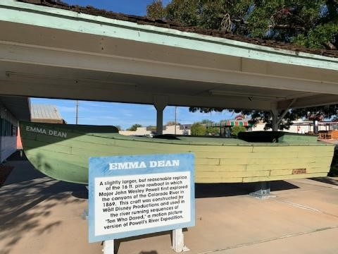
Coming into Page, we had been surprised to see signs for boats and boat repair, as there was no obvious water in sight. But not far away is the Antelope Point Marina, on one of the inlets of Lake Powell. It’s hidden from view until you get to the rim of the canyon. There’s a parking lot with a visitor center, and from there a very steep paved path down the hill to the edge of the cliff, and an even steeper ramp from the cliff to water level. Fortunately, they do have shuttles that can drive you down and back over a (steep) construction road. We started the walk down but stopped short at the ramp. No way were we going to make it down in one piece. Fortunately, an empty shuttle came by, and the driver offered us a lift, depositing us at the restaurant at the bottom. We had a lovely lunch by the water, then went to the call box to request a shuttle to pick us up for the return trip. They were experiencing some problems on the access road—a large maintenance truck was having difficulty negotiating a curve -- and the shuttles could not make it past. It would be an hour before we could be retrieved. We sat by the water for about 45 minutes, which passed pleasantly, chatting with several others who were also waiting, and finally, a water shuttle came for us. It deposited us on the opposite shore, where a land shuttle picked us up and drove us directly to the parking lot. So, we enjoyed a bonus boat ride! Always look for the silver lining!
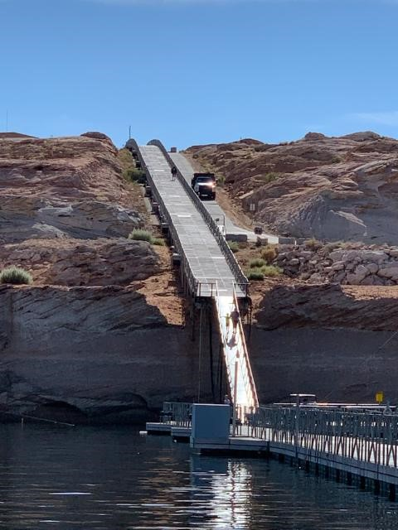
Continuing on, Grand Staircase-Escalante National Monument was next on the itinerary. We had booked the Entrada Escalante Lodge, thinking it was an official lodge of the National Park System (Rosemary thought that; I didn’t). It wasn’t, but it turned out to be a lovely motel with about 8 units in cabins; it was nicely appointed and had all the touches of a B&B except the breakfast. The owners were very nice and gave us good suggestions for dining and sightseeing. Despite the on-and-off rain, we set out intrepidly. The rain and fog refused to let up, but we soldiered on. Continuous switchbacks on the two-lane road made for an interesting, if slow, ride. On one stretch of about four miles, we were driving on the ridge of the mountain, with about 10 feet on either side between us and Eternity. It was a white-knuckle drive for Bob; I had white knuckles, too, and I wasn’t even driving! Although it was scenic, the weather refused to cooperate, so, reluctantly, we turned back (over those pesky four miles and switchbacks) and continued the drive to Bryce Canyon. The first picture below is one of the switchbacks, while the second shows one of the better sections of the road – we didn’t dare stop to take a picture of the really scary part with nothing on either side.
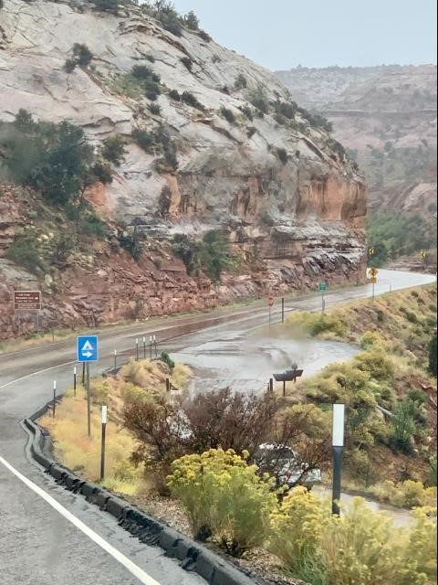

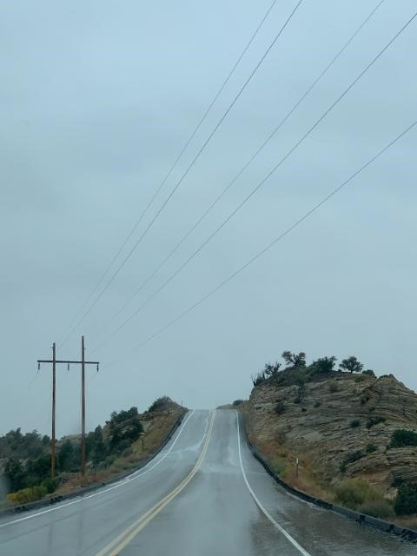
We’ve been to Bryce before in good weather, so the fog provided a new perspective on old views. The park is known for its “hoodoo” formations – tall rock spires rising from the basin. (They are also known as tent rocks.) There are trails to hike if you’re so inclined, or you can stay on the park road. Although the fog was persistent and thick, it was not nearly as difficult as Escalante; the roadway is wide, well-maintained, and well-marked as it circles through the park, offering frequent scenic overlooks along the way. (Tip: If you plan to visit several National Parks, get an annual pass; it will pay for itself. Better yet, if you are old enough, get a Senior Pass that’s good for a lifetime. The passes are per vehicle, not per person, so fill up that car!) At one of the overlooks, we found the resident raven. At least I’m pretty sure it’s the same one that was there last time, cawing and begging for food from the tourists and posing for photos.
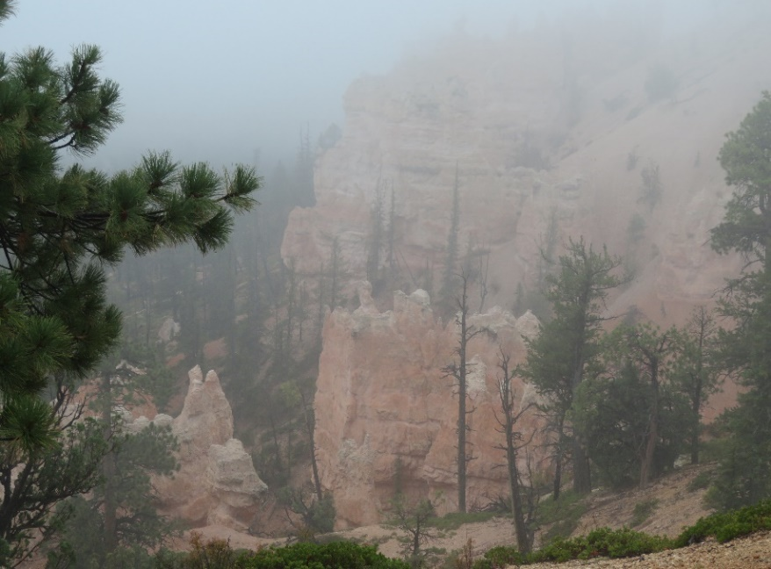
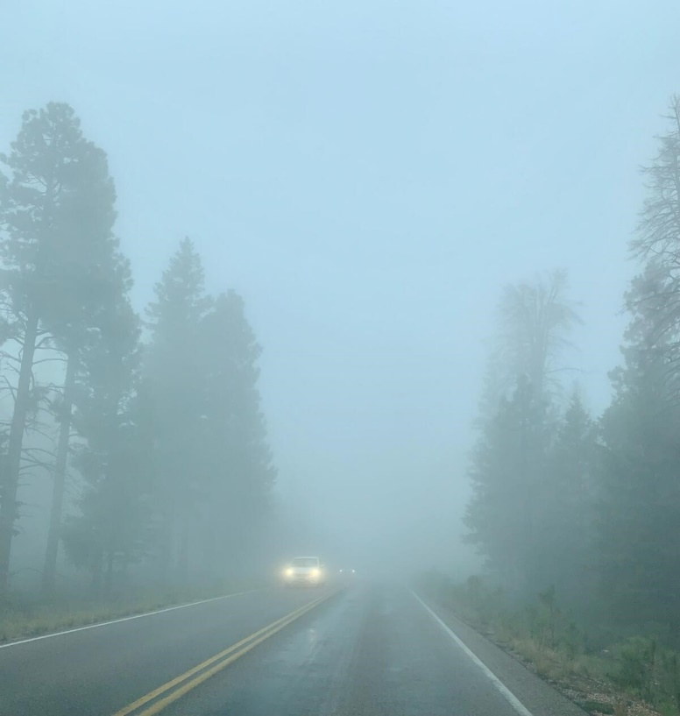
By now, we were hungry. The Lodge normally offers full dining services, but because of COVID, it’s limited to carry-out. We opted for elk chili, a good choice for a cold and rainy day. The restaurant was very Covid-aware, as evidenced by their social distancing sign.
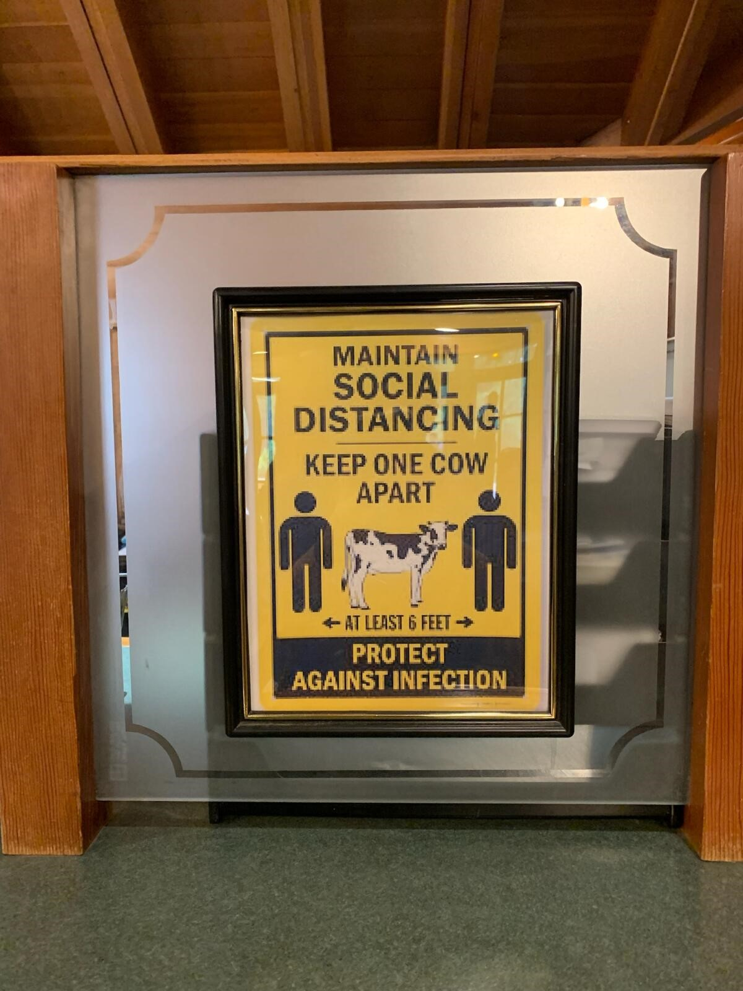
Back in April, we had tried to visit the Grand Canyon during the first week it reopened to the public. We attempted to enter by the South Entrance, waiting patiently in a line of cars that inched forward at turtle speed for at least half an hour. After rounding a bend in the road, we could see the entry booth; we also saw a sign that indicated a two-hour wait to get to the booth. Calculating the time it would take to get in, the probable lack of parking, and the likely number of tourists sharing the space, we prudently pulled out of line, turned around, and planned for another day (in October).
The town of Williams takes pride in being the last town on historic Route 66 to be bypassed by Route 40. Located about 60 miles from the Grand Canyon, it’s about two miles long and consists of two one-way streets a few blocks apart. It also boasts a train station, which offers excursions to the Grand Canyon. Problem solved. We made reservations for the train and a hotel. The excursion is a very popular attraction, and reservations ARE necessary, not only for the train in general but also for the particular car you wish to ride in, as the cars vary in price. Tickets can be purchased online at the Grand Canyon Railroad website.
We and six hundred of our closest fellow tourists met at a small outdoor theater for the 9:00 a.m. gunfight. Most of the actors wound up “dead” but rose to the occasion to take photos with the crowd. We saw them later, on the return trip, where they appeared “out of nowhere” to rob the train. Each car has a dedicated host(ess) who mingles with the passengers, answers questions, and provides information about what you are seeing. Several musicians pass from car to car, serenading passengers and taking requests. It’s not Broadway, but it’s fun. The ride to the Canyon takes about 2 ¼ hours, and you have three hours to meander, hike and grab a bite to eat. Then, it’s onto the train for the ride back to Williams.
The weather was cool and humid, with wisps of fog and low-hanging clouds when we deboarded at the Canyon, but we managed to get some photos before it started to rain. The colors of the Canyon were muted pinks and purples, ochre, and dusty green. Just looking out over the vast terrain and a mile down to the canyon floor is an awe-inspiring experience. Like looking at a star-filled sky, it makes you realize what a tiny part of the cosmos we humans are.
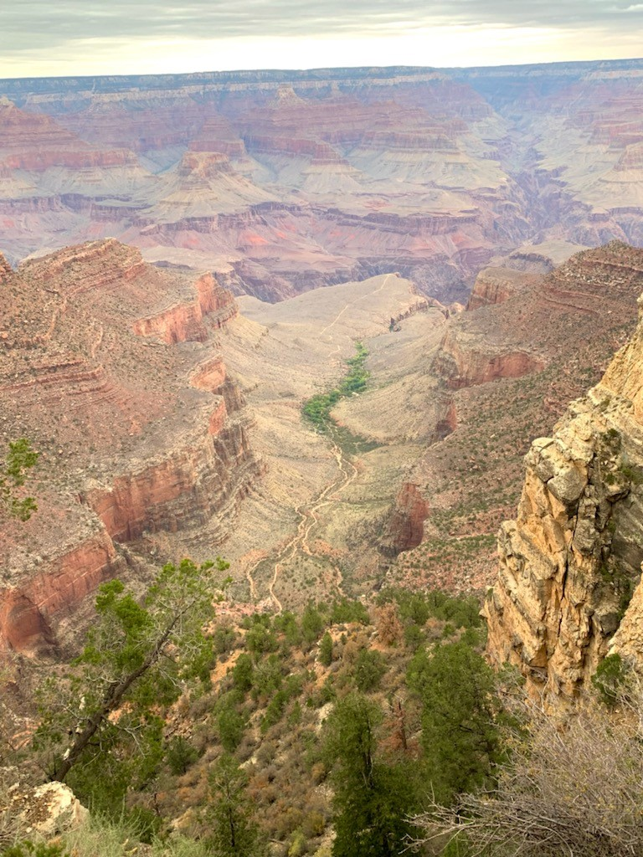
When the train arrives back in Williams, it’s around 5:30 p.m., and 600 hungry tourists descend on the town. (Tip: don’t even try to get into the restaurants on the street closest to the tracks. Walk a few blocks to the other main drag, and you’ll be more likely to get a table without having to wait an hour.)
On our last day of this leg of the tour, we visited Bearizona, just two miles outside Williams. Yes, it sounds like a hokey tourist trap, but it’s not. There is a drive-through section that features wildlife indigenous to the area: wolves, bears, bobcats, buffaloes, among others. Windows up and doors locked for the bear and wolf areas! The animals pay little attention to the human gawkers and just do what they do. If they start to approach the car, you just drive slowly along. It reminds me of the old joke: “If a bear chases you, you don’t have to be able to run faster than the bear; just run faster than your companion.” Next is a walk-through area that is like most other zoos, with smaller animals - raccoons, bobcats, badgers, foxes, baby bears, skunks, porcupines, otters, mountain sheep, etc., and one rather pretentious albino peacock. They have educational programs, and they rehab injured animals for return to the wild. Definitely a worthwhile visit.
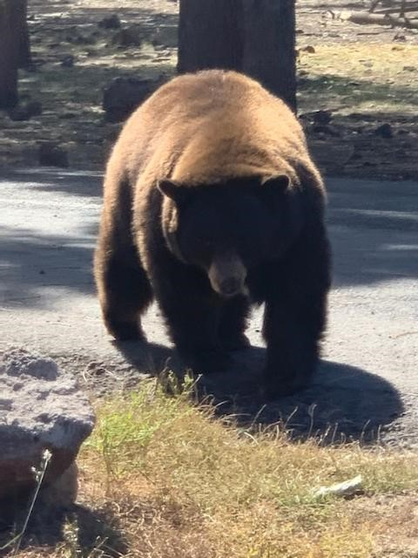
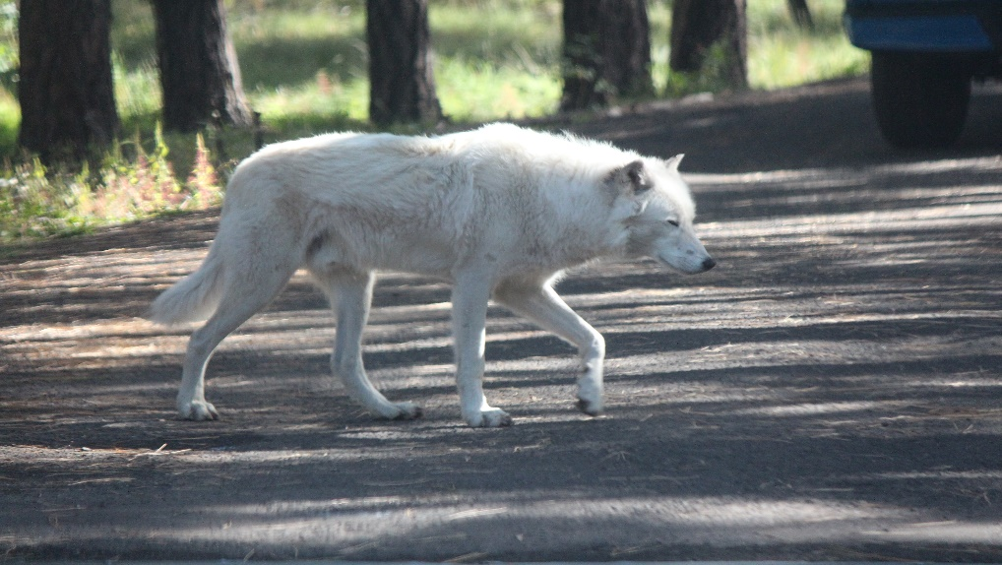
There are 4 things we either learned, or had reinforced, during this swing up north.
- In this part of the country, the gas stations may be far apart, so unless you have at least 2/3 of a tank, don’t pass up the next station you see, even if their prices seem high.
- Same applies to food – unless you brought it with you, there might not be a restaurant for another couple of hours.
- Same applies to bathrooms – for the same reasons, since these are located almost exclusively in gas stations and restaurants.
- At least 2 or 3 times a day, you will be passed by an a-hole driving a pickup going uphill on a curve in a no-passing zone. Although your urge will be to display a certain hand gesture, just be ready to slow down or even hit the brakes to avoid prematurely and permanently ending your own adventure. And yes, the picture of the Escalante uphill road was one where we were passed.
We left the wildlife and woods behind and set off down the road to Phoenix, where we had reserved a Rodeway Inn for a week. It had been listed as a three-star establishment. It was not. It turned out to be in a somewhat sketchy part of town and appeared rather down-at-the-heels when we drove up. But hey- it’s just a place to sleep. Walking into the room felt like we had walked onto the set of a bad gangster movie: there was a spray of holes on one wall, the door lock had been repositioned, leaving the old holes, there was no refrigerator, the door to the cabinet was broken, there was no chair, no TV remote, no phone, and no towels, even though it was now past the four o’clock check-in time. Bob went back to the manager’s office to inquire about towels, at a minimum; “they’ll be there when they get there,” was the reply. I found a housekeeper who apologized, then went on to rant about the “Witch of the Laundry,” who apparently doled out towels like they were gold. It now being six o’clock, there were still no towels, and we’d had enough, so Bob returned the keys to the office and told them to cancel everything. We spent the next two days at a real hotel, then moved on to a resort in Mesa. (Tip: If you find yourself in a similar situation, cancel with the home office of the chain, request a refund, and notify your credit card company in writing – it can be an email – of the disputed charge. Also, take photos, if appropriate, to back up your claim.)
So now we are relaxing at a lovely resort, catching up on the blog, and whiling away the time before we head to San Diego for our cruise. Although we had not planned to stay so far from Phoenix, we managed to get a last-minute booking at the Westgate Painted Mountain Golf Resort in Mesa. It is very lovely, with lots of facilities for kids plus a large pool and two hot tubs. The front staff are friendly and helpful. The second day we were here, a car traveling much too fast on the main road in front of the resort managed to topple a telephone pole and end up on its back. This resulted in a power outage for a couple of hours and no TV service for a couple of days – none of that, of course, was the fault of the resort. They had workers out there constantly helping to restore service.
We did not know the Mesa area very well, and the resort’s restaurant did not serve breakfast on weekdays, so we chanced upon a nearby breakfast place called the Cozy Corner Café. What a stroke of luck – this turned out to be a model of how any restaurant should be run. The food was good, decent-sized portions, and there were various choices from $3-4 for bagels and pancakes up to about $12-13 for specialties, like Eggs Benedict, our favorite. What sets this place apart from most other restaurants in our long lifetime is how the place is managed: all the wait staff cooperate, so if there is a plate that needs to be cleared, any staff member who comes by clears it – they don’t wait for “that table’s waiter”; there is a pleasant young man who circulates offering refills on coffee or topping off your water glass; if you try to share a plate, unlike most restaurants that consider this a hassle or charge extra, they happily divide the dish in the kitchen and bring it out on two plates; after our second visit they remembered what we liked (coffee for Rosemary and tea for me) and asked if we wanted Eggs Benedict and a pancake again (we changed our routine for the third visit). They obviously do a lot of repeat business, as they greet some of the customers by name, and there are probably some who come almost every morning. Enough said – if you are in the Mesa area you can’t go wrong here.

