Sedona – September 2021
Sedona—Red Rock Country. Everywhere you turn, amazing formations loom over the countryside. How it’s changed since the first time I visited in 1996. Back then, SR 179 was an open road, and Sedona’s center was a few shops clustered together on SR 89A at the “Y.” As I traveled toward Sedona, Bell Rock rose above the rest of the landscape, but I couldn’t find the trailhead. There were no markings. Flash forward several decades and how times have changed. That same roadway has ten traffic circles and is replete with resorts, shopping centers, and private housing. Uptown Sedona has restaurants, shops, and galleries. Art is everywhere!
Don’t get me wrong—there are still vast stretches of untouched land that are protected as part of the State Park system, and it is as breathtaking as ever. It is also clearly marked, so you don’t go flying past a formation you really want to explore.
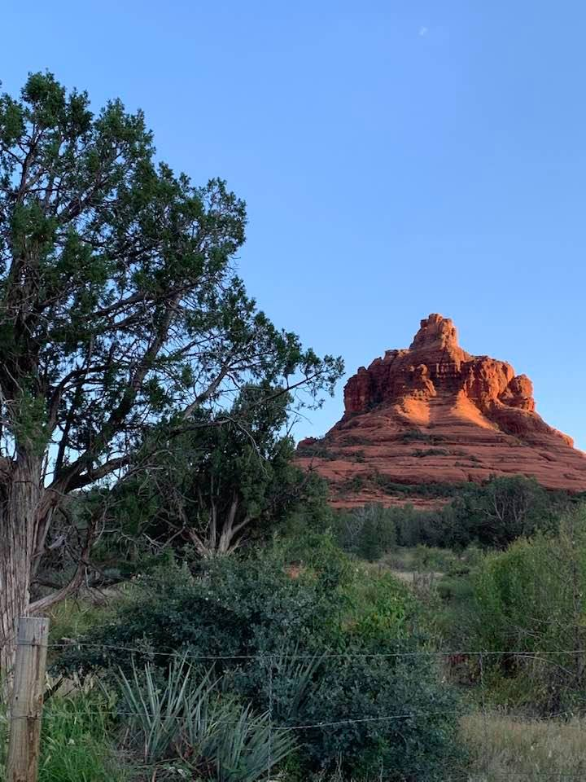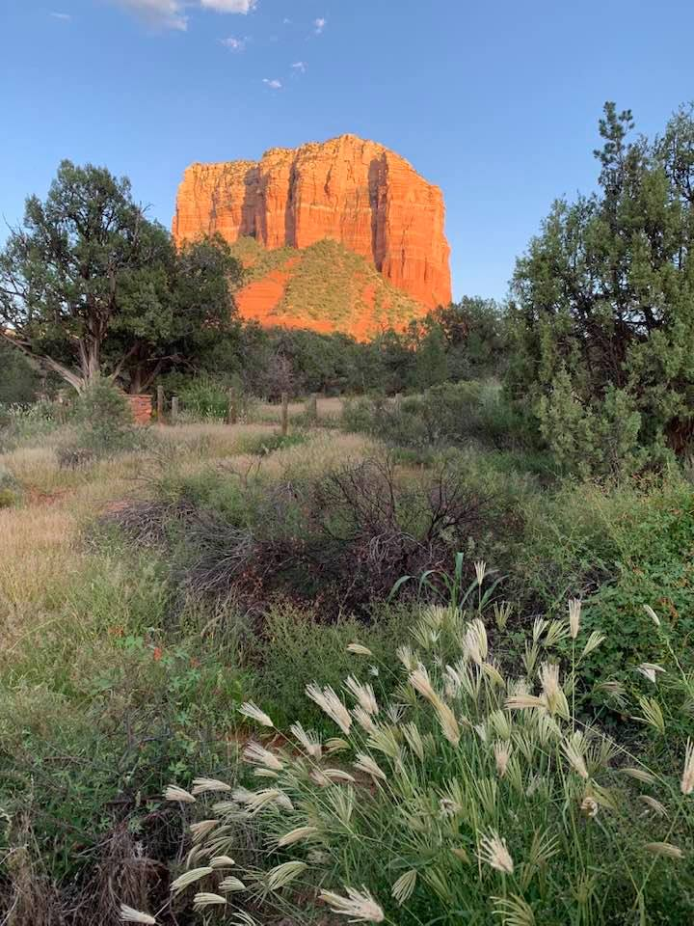
This area is known for its vortices—areas where the earth’s energy is powerful--and there are five popular vortex locations in Sedona: Cathedral Rock, Bell Rock, Boynton Canyon, Airport Mesa, and the Chapel of the Holy Cross. Because of this, Sedona, apart from being a popular destination wedding site, is the New Age capital of the World. Admittedly, there is an overabundance of crystals, incense, aura photographers, and psychic readers, but don’t dismiss the energy out-of-hand. I, personally, have felt the energy at Bell Rock and the Chapel, not so much at the Airport or Cathedral Rock. Boynton Canyon is on the list this trip, and we shall see. They are all worth visiting, as the panorama is breathtaking. There are those who say that the whole thing is a tourist hoax, but consider that this was sacred ground long before Europeans set foot here. If you are receptive, you’ll feel it.

Oak Creek has provided water here for centuries. One of the best-known spots to cool off is Slide Rock, just north of Uptown Sedona. Be aware that parking is limited, and you’ll need a parking pass, which you can obtain in just about any location with a trail. It’s usually crowded, so go early. It’s also cold. And bring an old bathing suit that you don’t mind being shredded on the rocks. If it’s serenity you seek, follow 89A north, and you’ll find quite a few spots where you can pull off the road and clamber down the hillside to the stream. It is rather steep but doable, even for someone with creaky knees and hips (like me.) The creek is shallow, chilling, and provides delightful relief from 100+ degree summer temperatures. (Don’t worry, you’ll get used to it!) I found that the cane I use when my bones rebel was perfect for stabilizing me as I walked in the water.
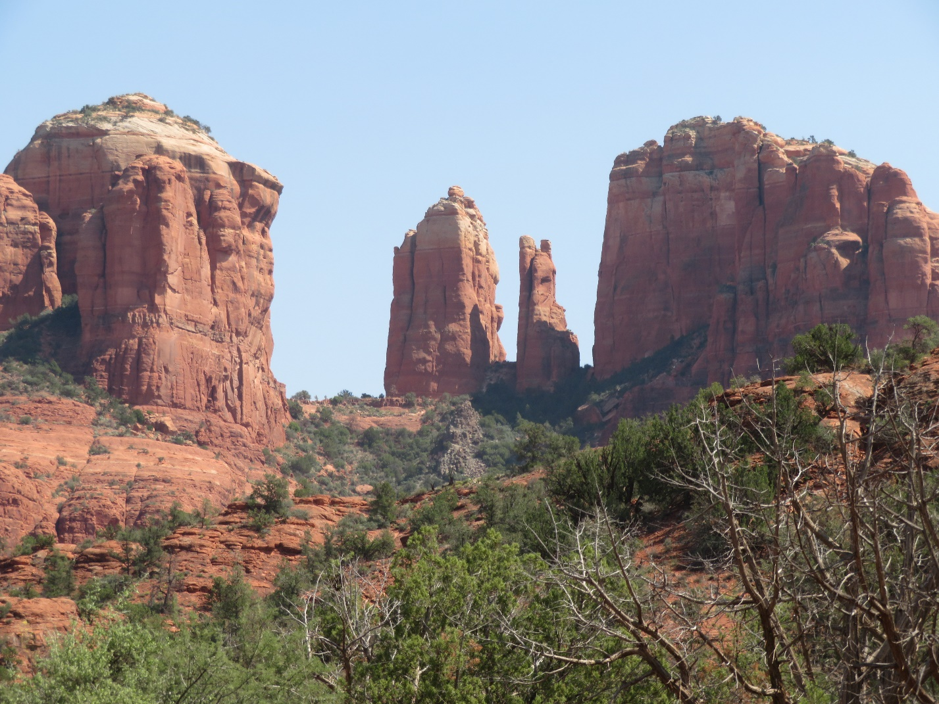
Cathedral Rock is the iconic symbol of Sedona and a must-do photo op. Take Verde Valley School Road to where the pavement stops and pick up the trail there. Years ago, we were enjoying the stream and a sort of mini Slide Rock when we noticed a group of people in formal wear descending from the street to a flattened area nearby. It was a wedding! Bob and I, along with several other bathers, were invited over to participate. As it turns out, the bride’s aunt lived two towns over from where we lived in New Hampshire. Yes, it’s a small world.
The major rock formations all have parking areas – sufficient space on most weekdays but crowded on weekends. They all have porta-potties and well-maintained trails that are accessible to everyone for at least the beginning of the hike. If you are not mobile at all, there are still beautiful views from the parking lots and highways. To visit the Chapel of the Holy Cross, you can drive all the way up, where there is handicapped parking, or park with the other cars and hop on one of the golf carts that shuttle people up the hill.
Page Springs Road is the home to several wineries, and we visited the Oak Creek Vineyard with friends Christine and Tim, who relocated from NH to Rim Rock. The winery is about 20 miles west of the “Y” on 89A. They produce small batches of really good wines – comparable to CA. Following our wine tasting, we drove north of Page Springs to the Sedona Wetlands and Nature Conservancy. These man-made wetlands treated us to the view of several golden eagles, waterfowl, and other flora and fauna.
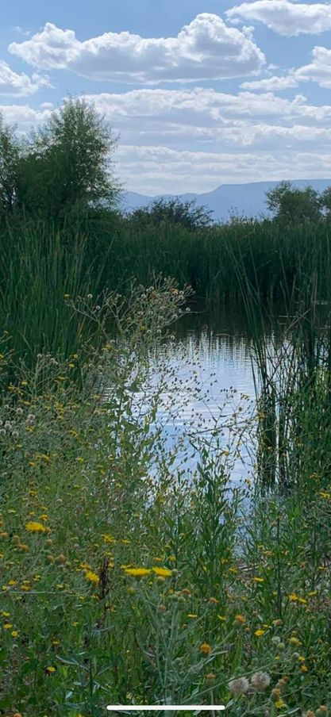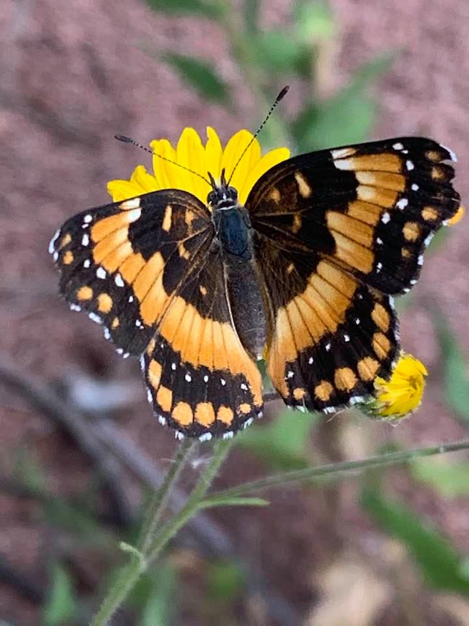
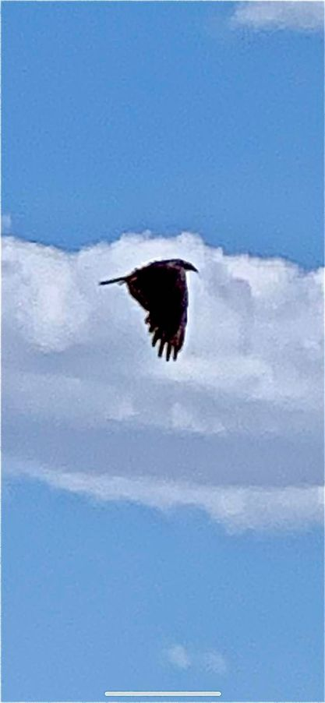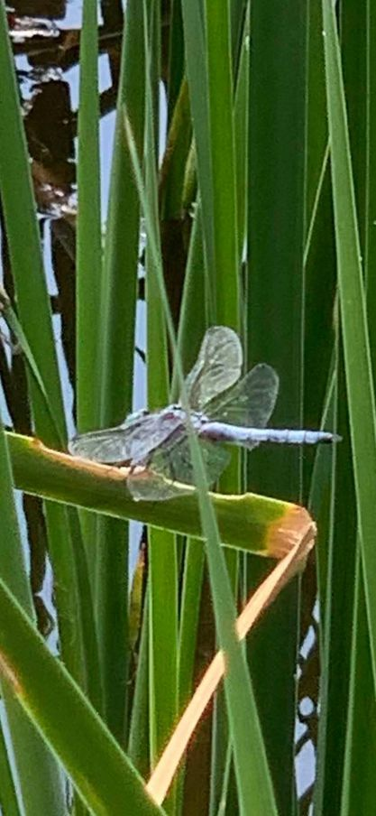.

Tlaquepaque Arts and Shopping Village in downtown Sedona is a destination unto itself. Built in the early 1970s, it is a painstaking re-creation of a typical Mexican village. Located on the banks of Oak Creek on SR179, south of the Y, it was built around 100-or-so -year-old, carefully preserved sycamore trees. The shops and art galleries are way out of our price range, but if you consider it a trip to a museum, you can spend a day or more there. Definitely worth a visit!
