Day 13 - Cartagena, Colombia
Officially known as Cartagena de Indias (the original Carthage is in Tunisia), the city was founded in 1553 on the banks of the Caribbean. It is completely fortified, to protect it from the pirates and privateers who pillaged the Spanish treasure ships. There are several forts positioned around the city, their cannons pointed to the sea. But at the Castillo de San Felipe de Barajas, the largest of all, they point toward land. Why? You may ask. Good question. If invaders were able to breach the fortifications, they would be caught in the crossfire from San Felipe. Located at the top of San Lazaro Hill, it dominates the city and the main gate in the city walls. The design was revolutionary: the pyramidal walls were able to deflect cannonballs. Invaders, if they made it that far, were forced into narrow passages. One particularly interesting feature, as you make your way to the top level, is a tunnel, built at about a 30 -degree angle. The invaders could not see the defenders at the top, but the defenders could see the feet and legs of the invaders and were able to pick them off as they attempted to ascend. (Tips: This is a strenuous tour. I was able to manage it, using my cane, but I doubt a wheelchair would be able to make it up the many ramps. The weather is generally very hot and humid: wear a hat, use sunscreen, and bring plenty of water. There are vendors (not nearly as aggressive as those in Guatemala) just outside the gates who will offer you all these necessities if you’ve forgotten them. Prices may vary.)

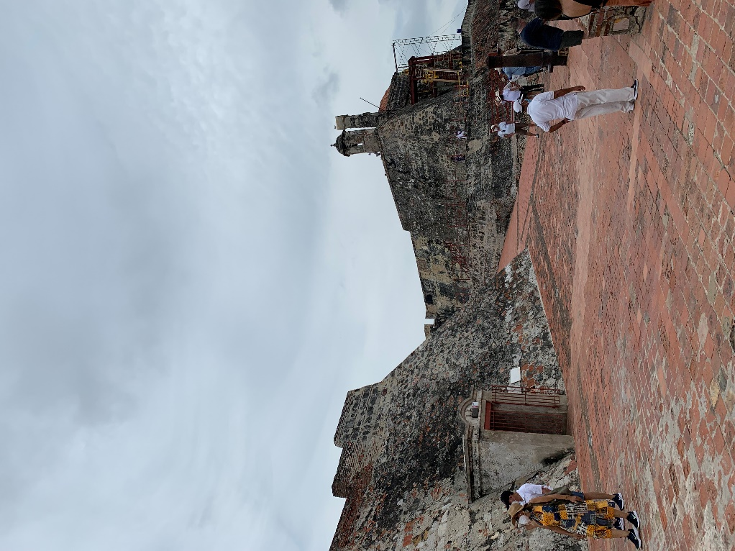
The Fort
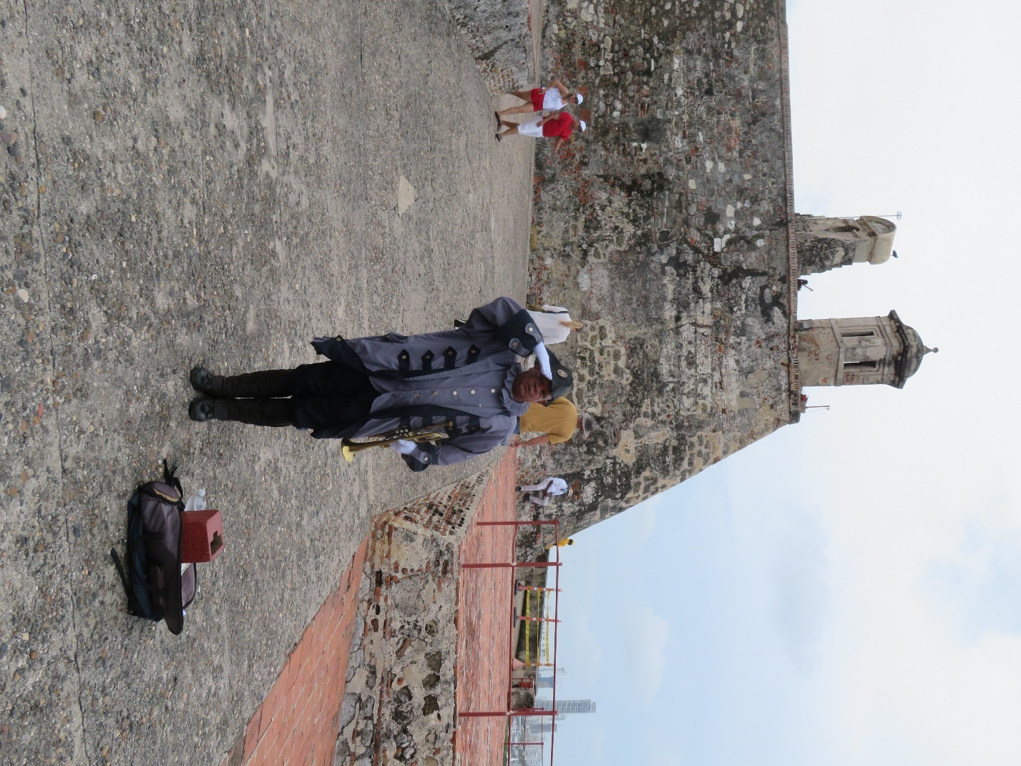
A Persistent Trumpeter
Back on the bus we drove through the old, colonial section. (In my humble opinion, it is far better than what we saw in Antigua.) We did a walking tour, passing brightly colored mansions with massive wooden doors. The houses tell a lot about the original owners: the higher the house, the higher the status – even if only by an inch or two. There were, of course, street vendors, but what caught our eye was a man painting with his fingers, on small metal sheets. They were really quite good, but we politely declined.
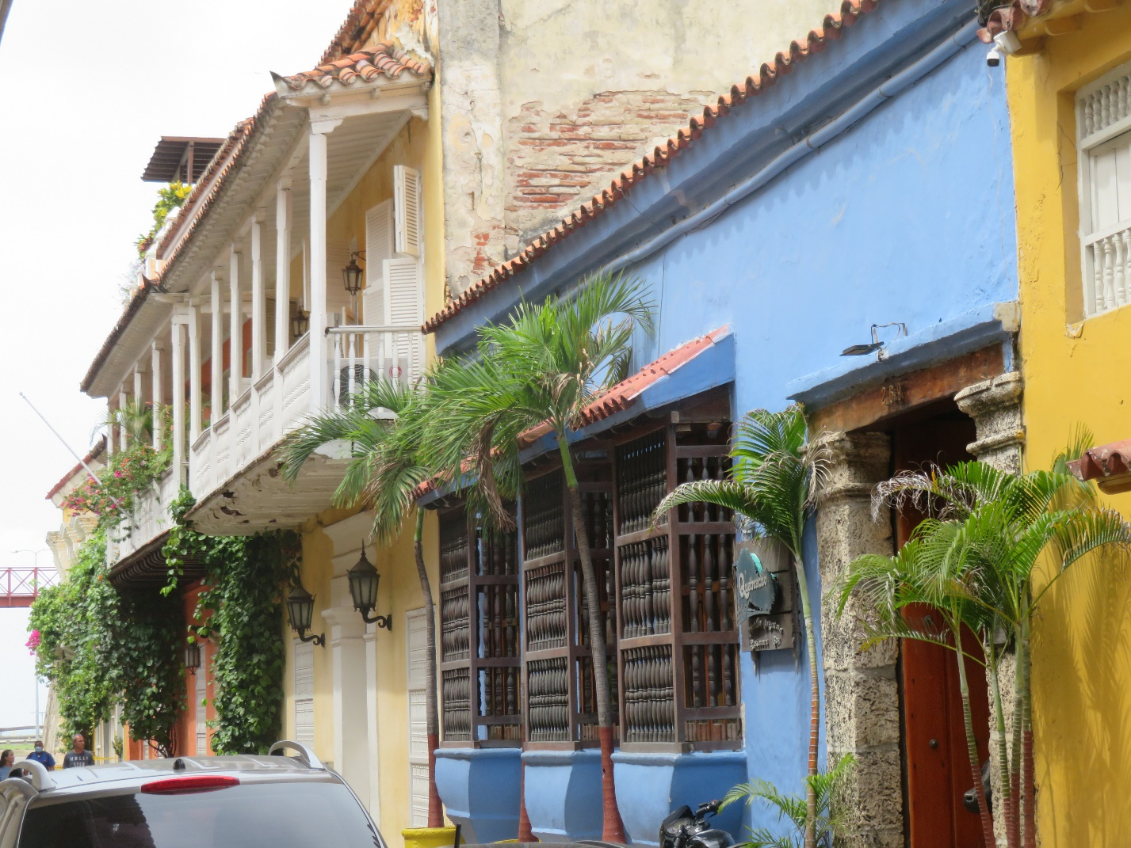
Spanish - Style Architecture
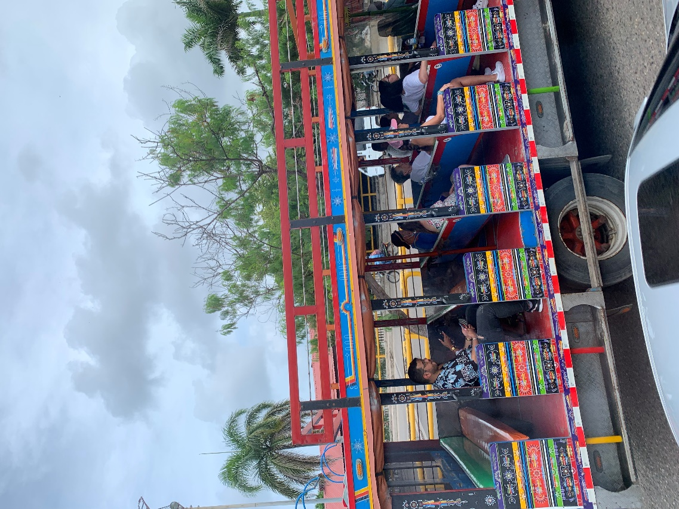
An Open-Air Bus
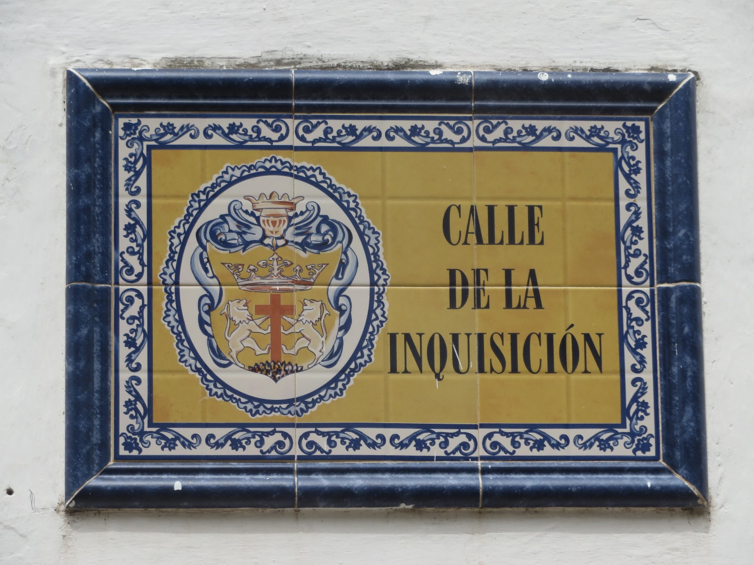
Outside the Museum of the Inquisition
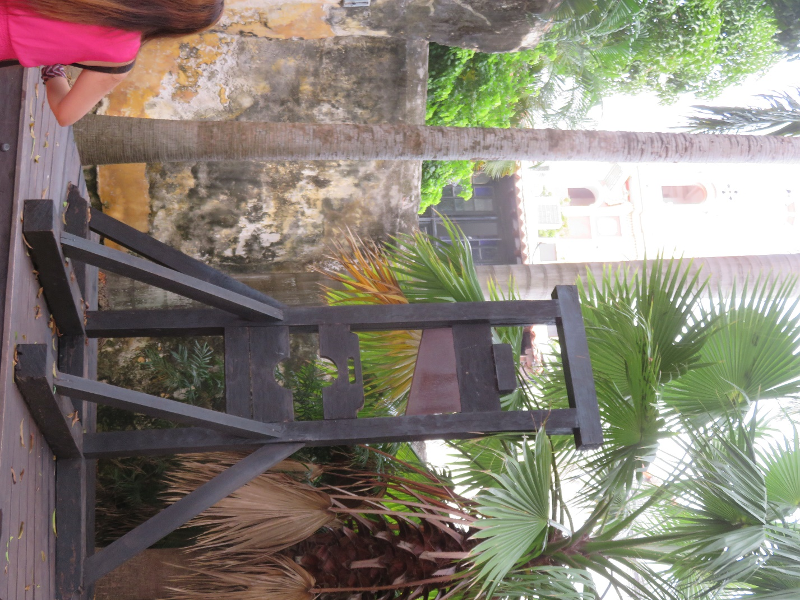
Inside the Museum of the Inquisition
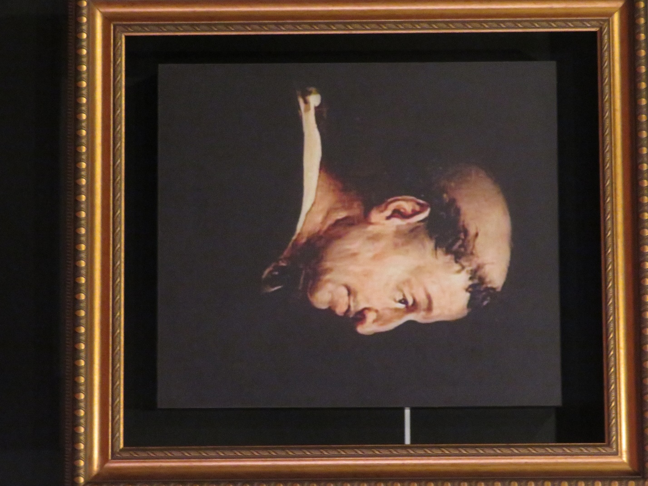
Torquemada Grand Inquisitor
We continued on to the Cathedral of San Pedro Claver. A Spanish Jesuit, his mission was to minister to the slaves that arrived in Cartagena, the main hub of the West African slave trade. It is said that over the course of forty years, he personally baptized more than 300,000 slaves. After he was canonized, his bones – or most of them, anyway - were brought to the Cathedral where they are displayed beneath the altar. Next door is the humble house in which he lived – now a small museum.
The Plaza de San Pedro, outside the Cathedral, offered a relaxing place to sit down and have a cold drink, while people-watching. Of course, there were vendors, of everything from “molas” – hand embroidered panels with designs of the San Blas Island Indian women – to hair ornaments, models of ships, paintings, leather goods, etc. A number of women wore ruffled, tricolor dresses representing the Colombian flag, and fresh pineapple headpieces. Of course, the photo op involved a small fee. Our guide told us not to even point a camera at them from across the plaza, as they were eagle-eyed, and would come to collect! A man was feeding corn to the pigeons, offering a chance for a photo with a bird perched on your hand. (I will not say that those birds were working for peanuts, because that’s just too corny.) We politely declined all offers until an ancient, little woman, selling inexpensive plastic fans, looked at us pleadingly and said, “Para comer.” (To have something to eat.) I caved. I didn’t need the fan, but she needed the three dollars more than I did.
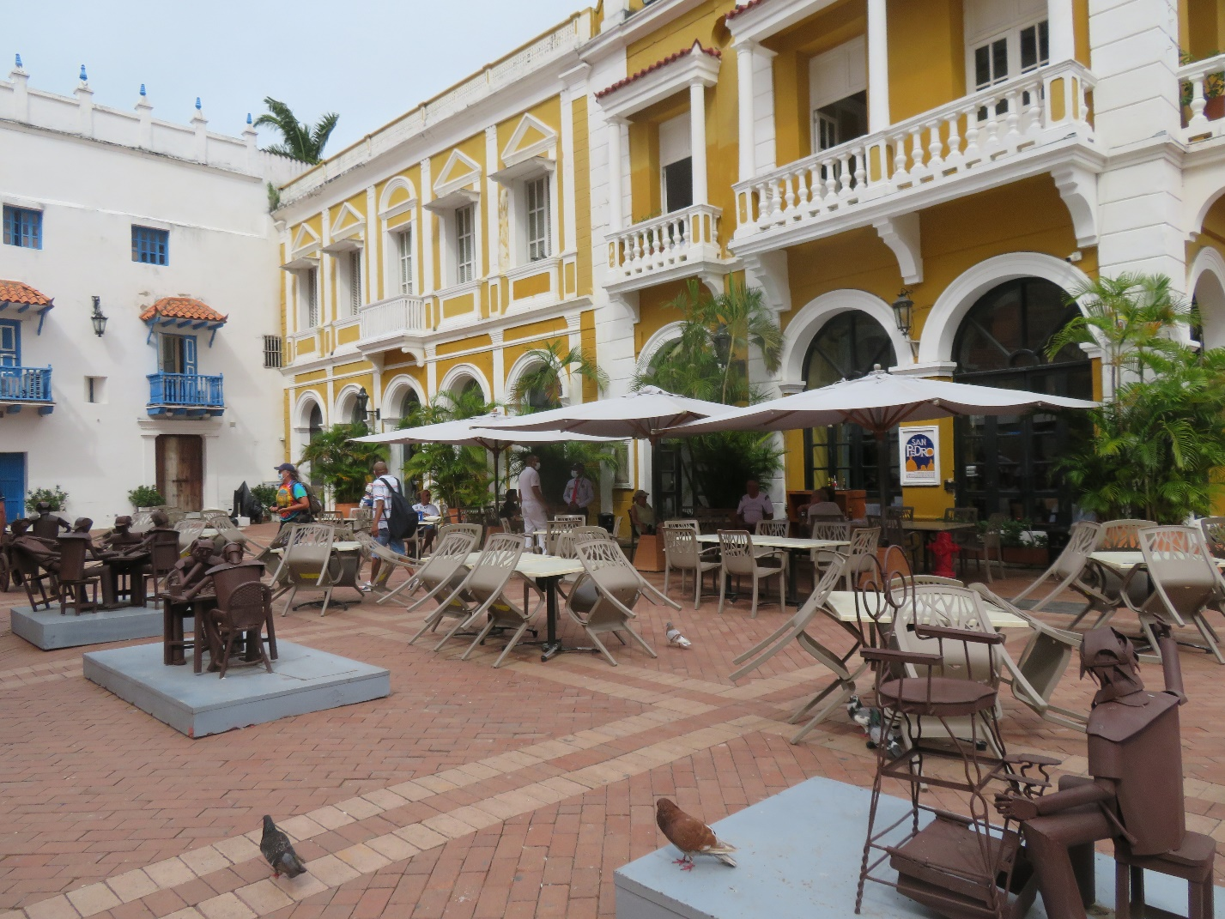
Plaza
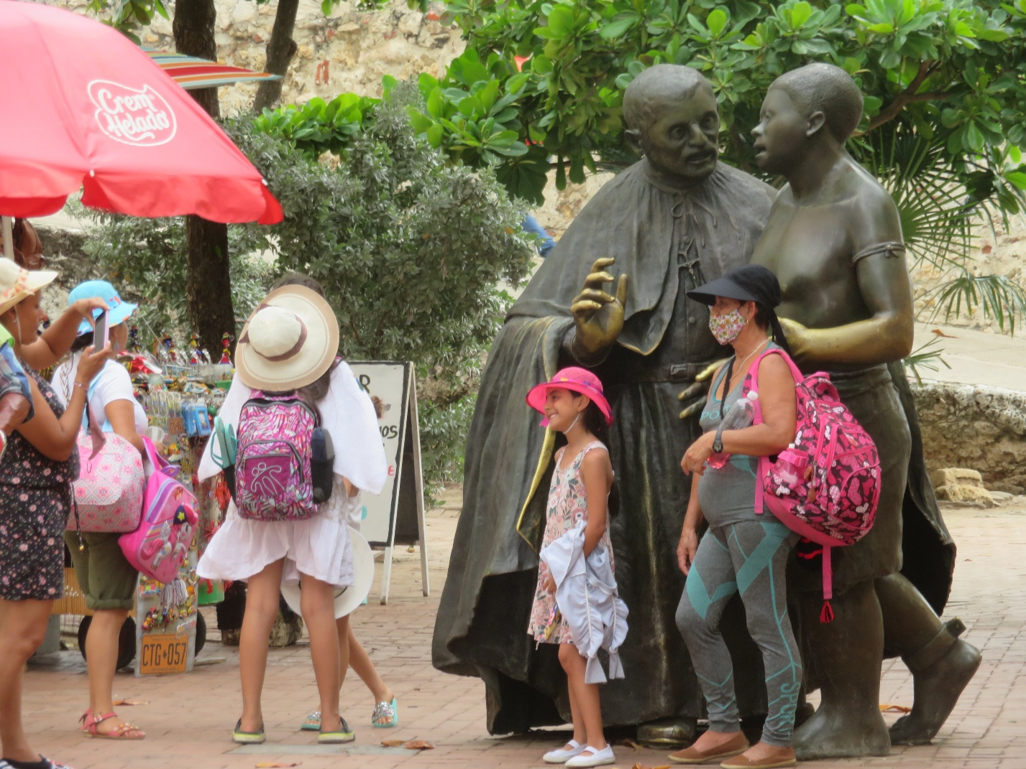Plaza
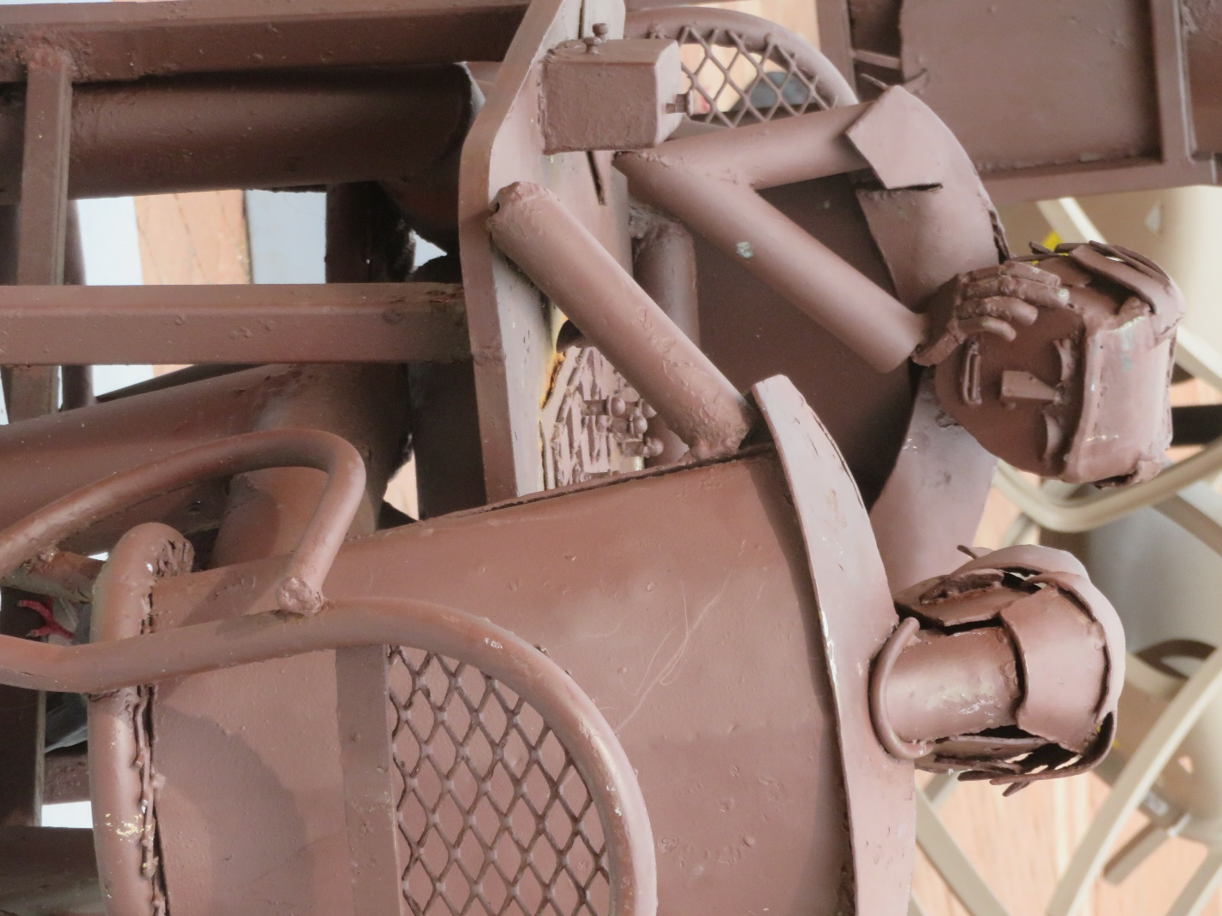
Plaza
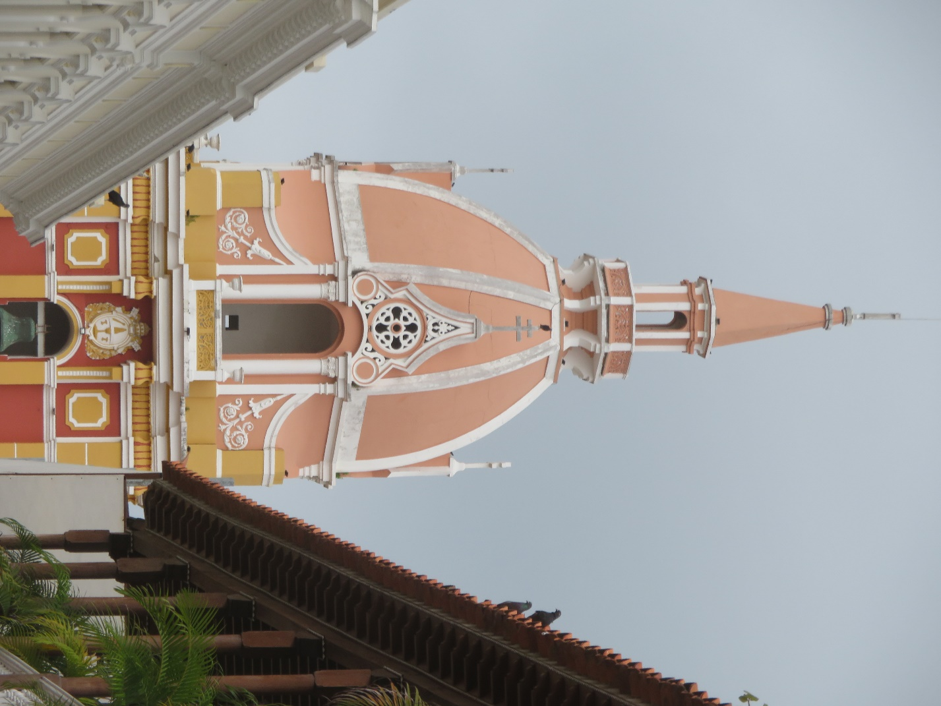
Plaza
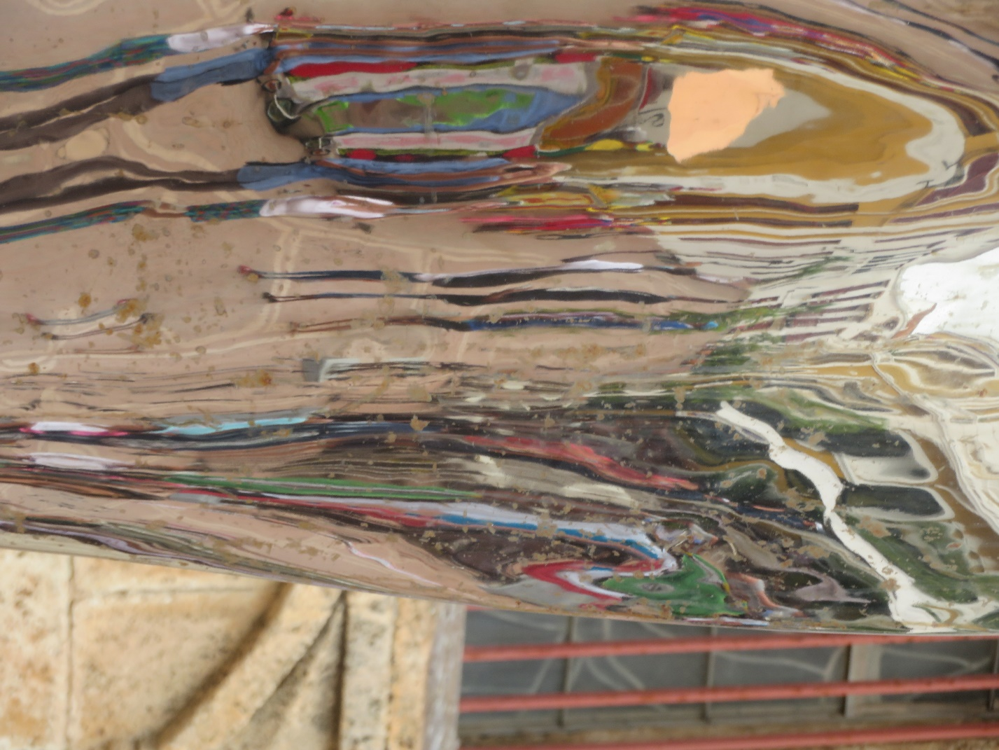
Plaza Reflections
A distinguishing feature of the entrance to the pier in Cartagena is a lovely garden with an aviary of exotic birds and some anteaters, monkeys and parrots roaming freely. It was the perfect way to end our excursion. We were so delighted, we lost track of time, and just managed to get the last shuttle to the gangway. Lesson learned. Always be aware of the time!
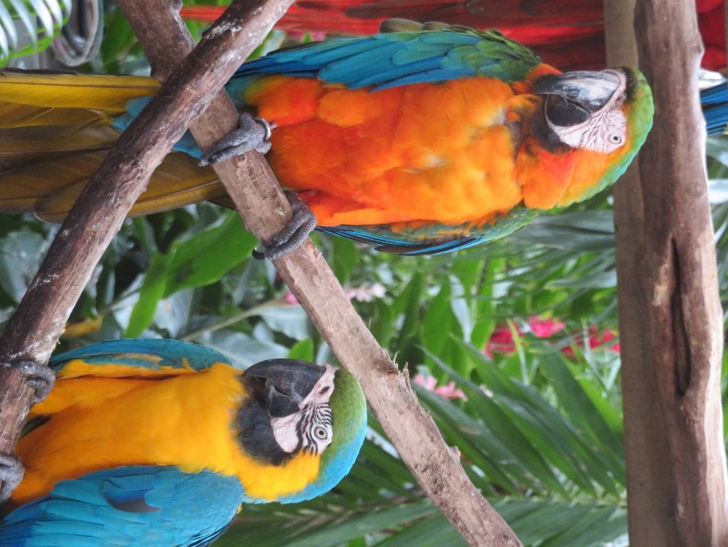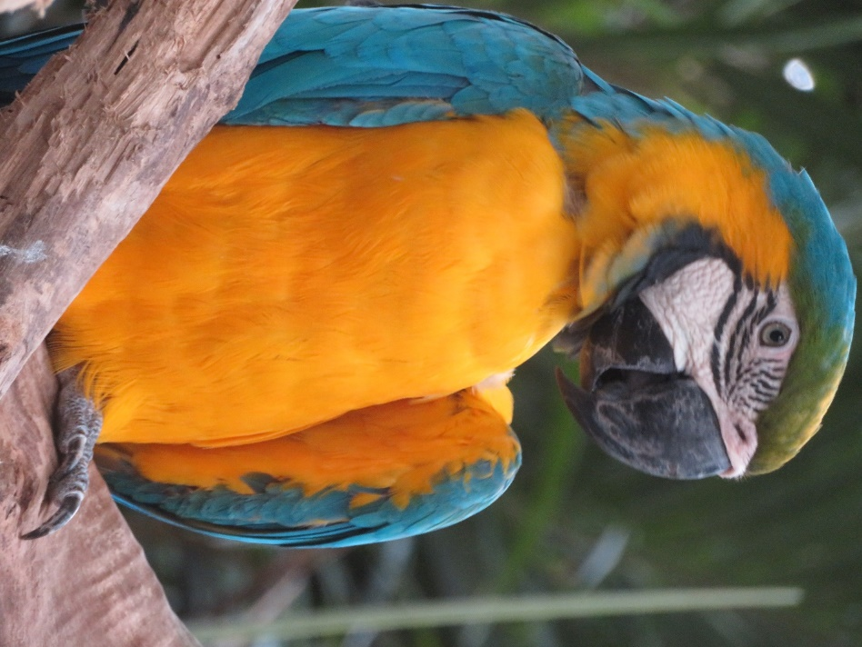
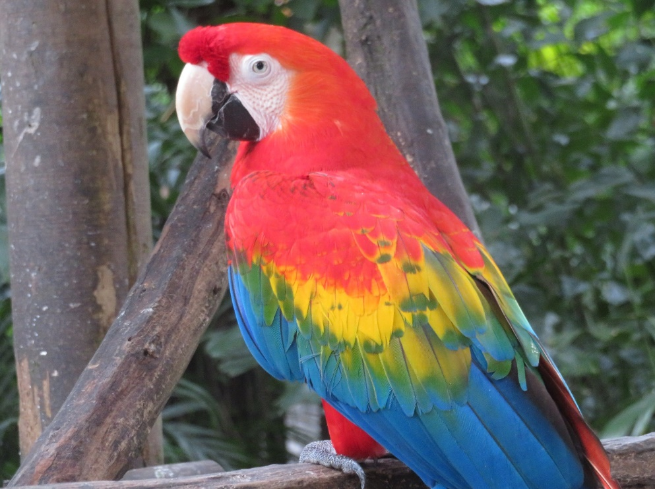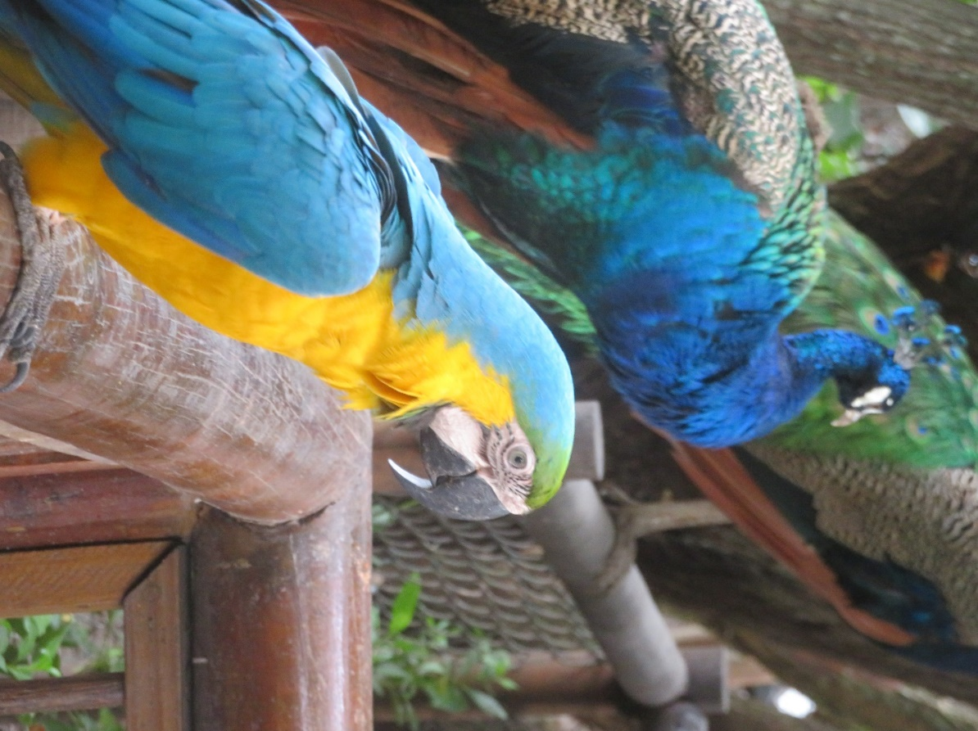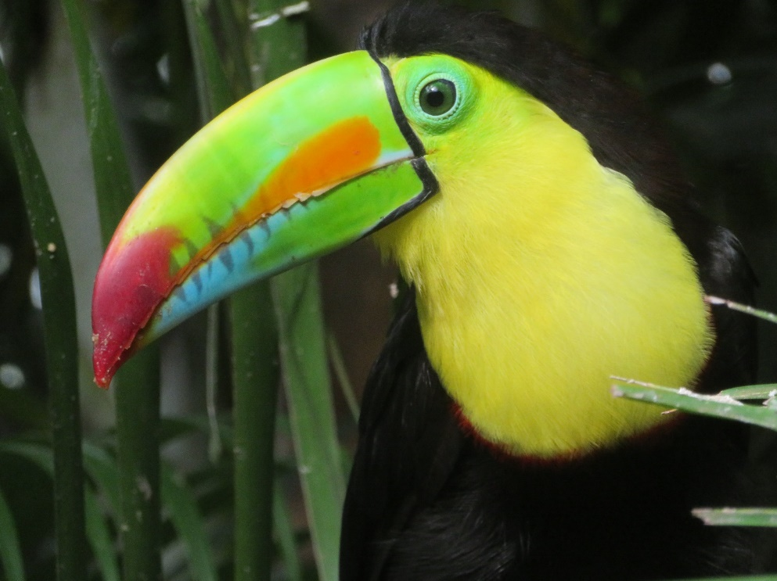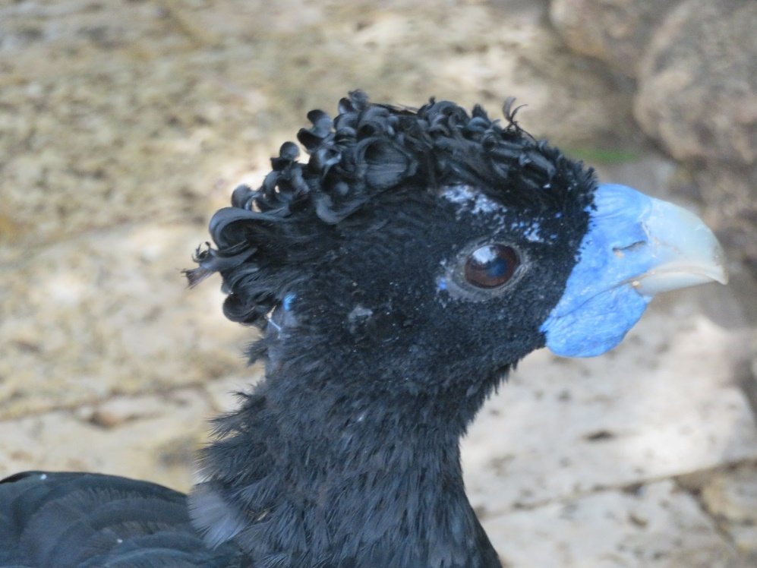
What a Variety of Species and Colors
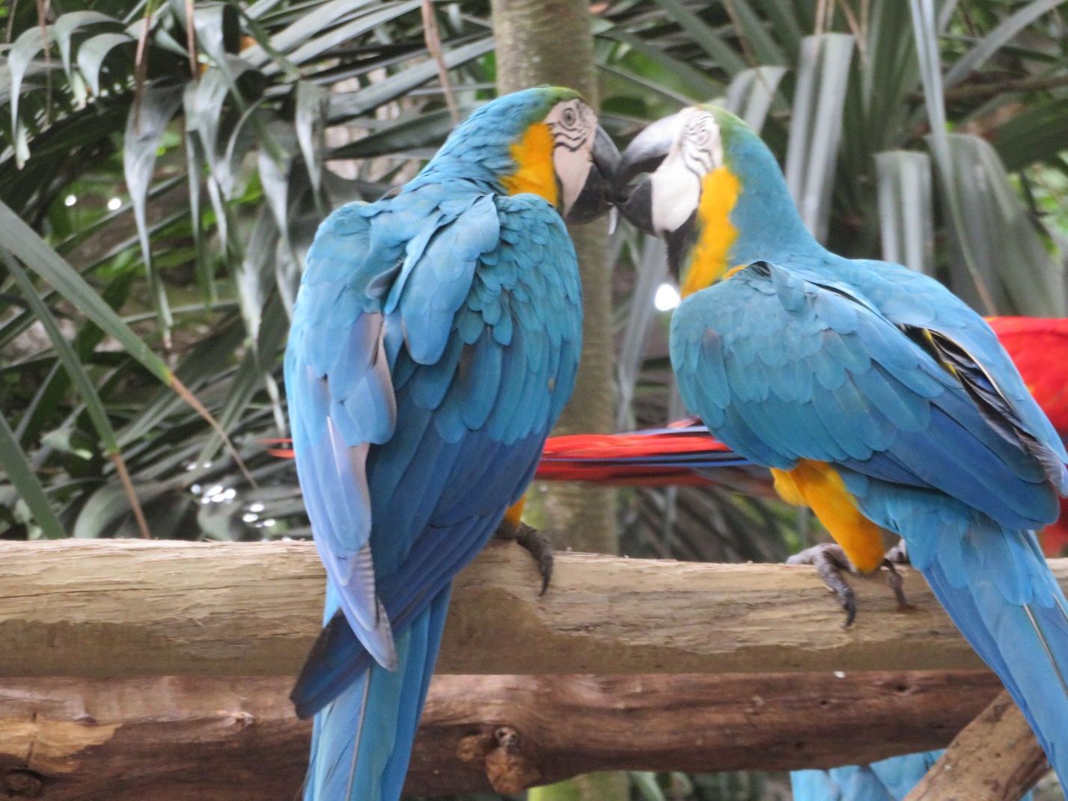
Anything One Can Do, Toucan Do Better

