Day 12 - Colon, Panama
In the evening, we docked in Colon. Because of Covid restrictions, and possibly safety, no one is allowed to leave the dock unless they are part of an official excursion. There were several offered; we chose to visit the Embera Indian Village. What an experience. A bus took us to the bank of the Chagres River, located in the Chagres National Forest. We boarded dugout canoes (enhanced with outboard motors) guided by young men of the village. After about 15-20 minutes we were helped out of the canoes and greeted by tribesmen playing music and women dancing. We climbed the hill to the village and had a brief orientation, led by our guide, who is, himself, Embera. Most of the people speak Spanish as well as their own language, and we were able to communicate directly with them.
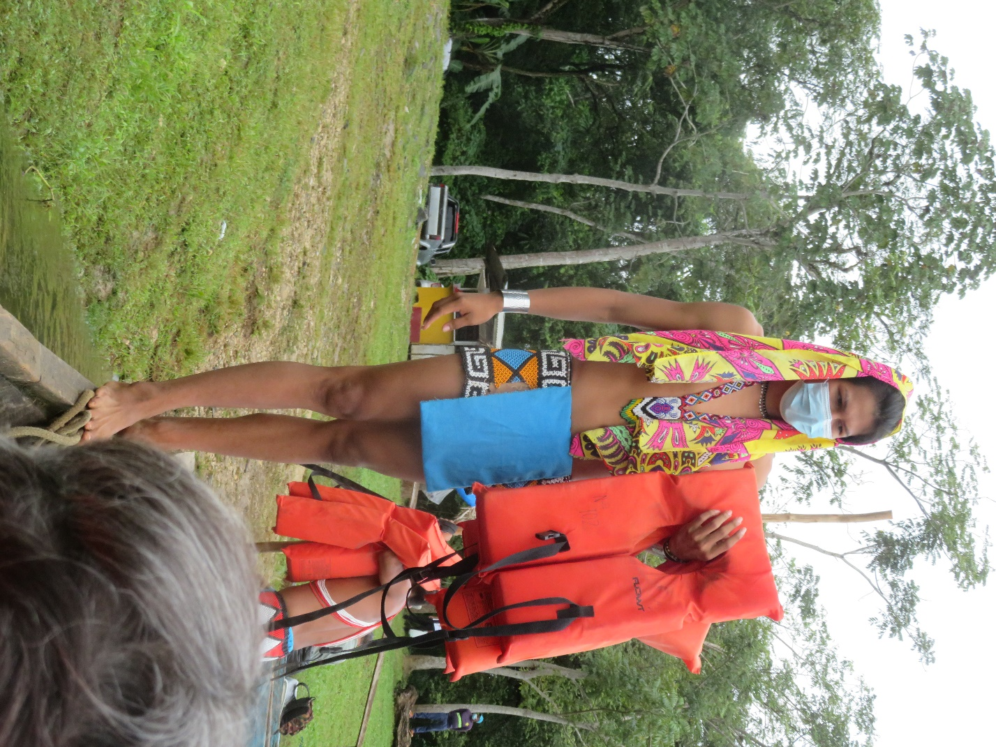
Modern Requirements
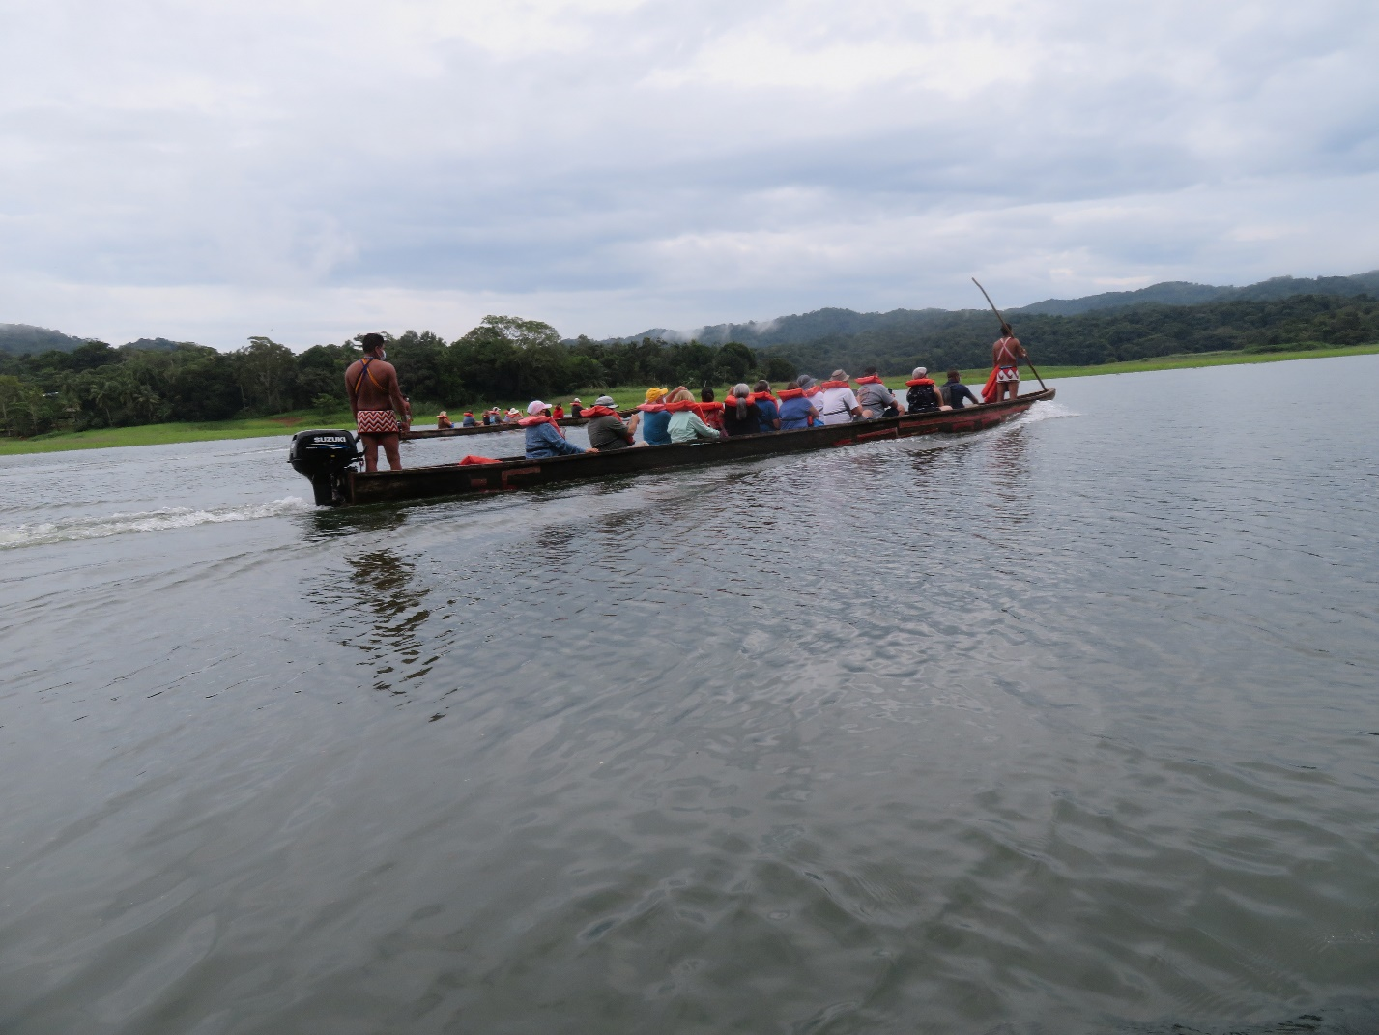
The Ride
They live such a peaceful, simple life. There are five villages along this part of the Chagres. Each is comprised of several families, who elect a leader; each is autonomous. They are, for the most part, self-sustaining. Cultural tourism gives them extra income. Each family had a booth where they sold masks, beaded goods, cloth and leather. Their food is simple, and everything comes from the land or the river. We enjoyed a lunch of grilled tilapia and plantain served in a banana leaf dish. (Watch out for bones!) After lunch they performed native dances, and invited us to join in. They are such beautiful people. Reluctantly, we said good-bye, climbed back in the canoes and made our way back to the bus, and the ship. As a side note, I posted photos of the villagers on Facebook, and got a stern warning that they were violating the community moral standards of nudity and sexualization of children. Seriously?? You be the judge.

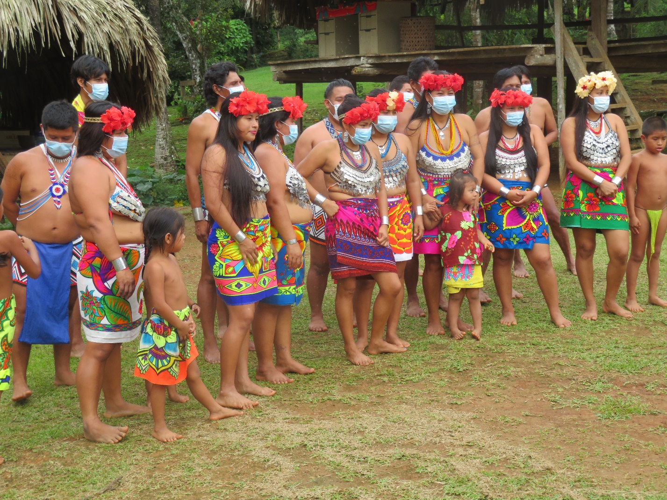
The Embera People
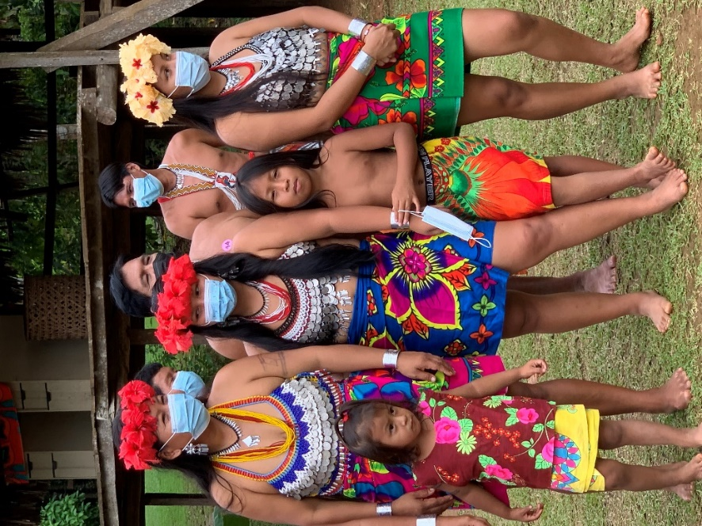
The Embera People
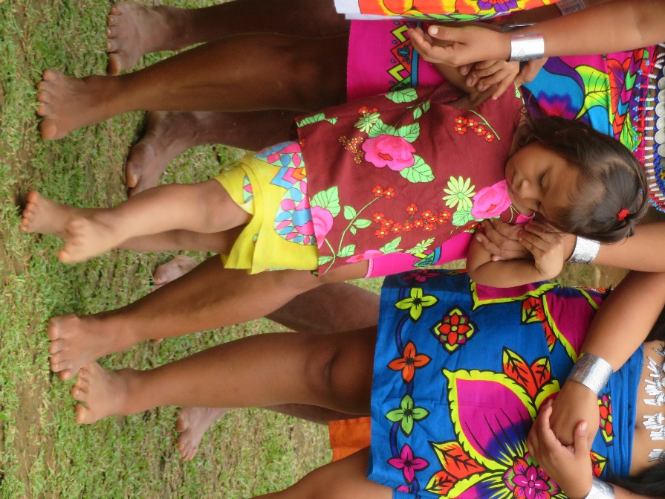
The Embera People
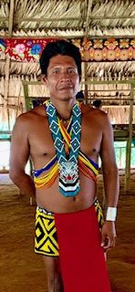
The Tribal Chief
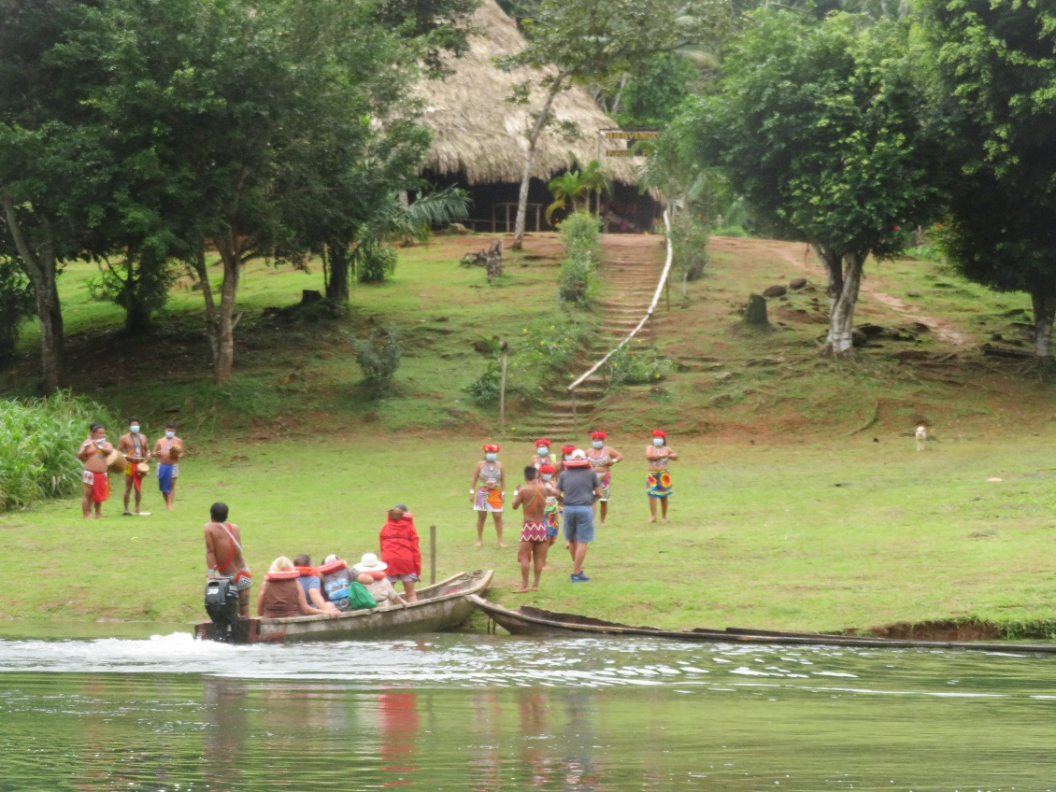
The Village
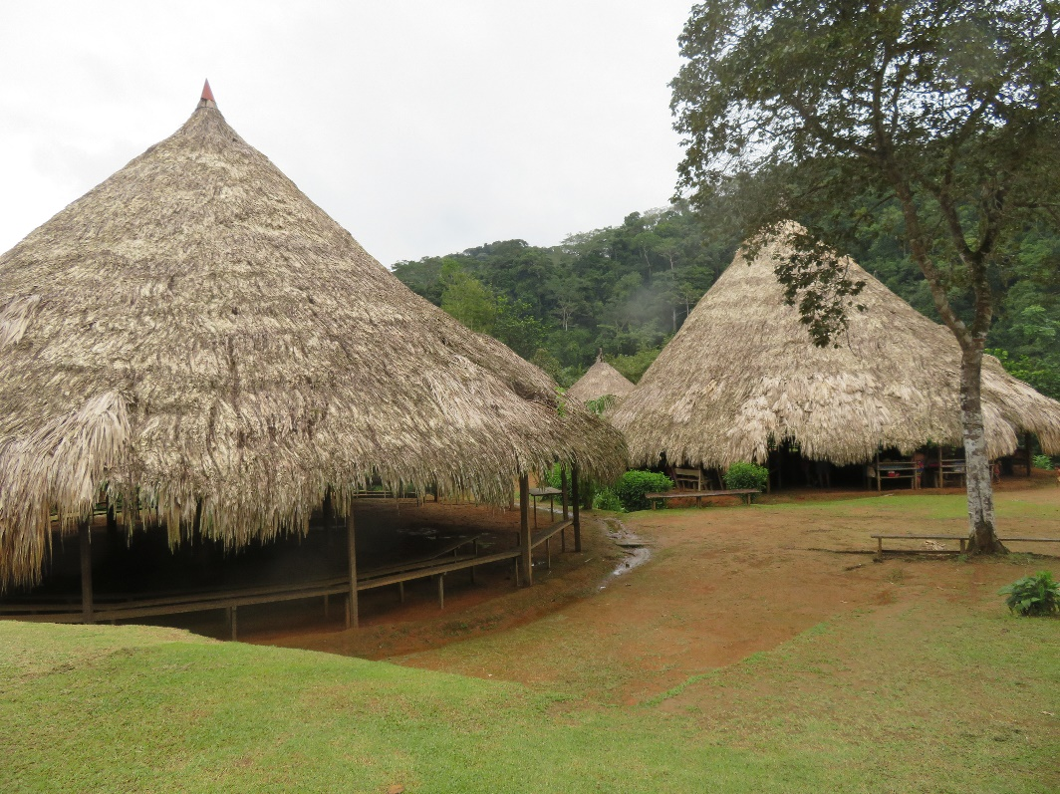
The Village
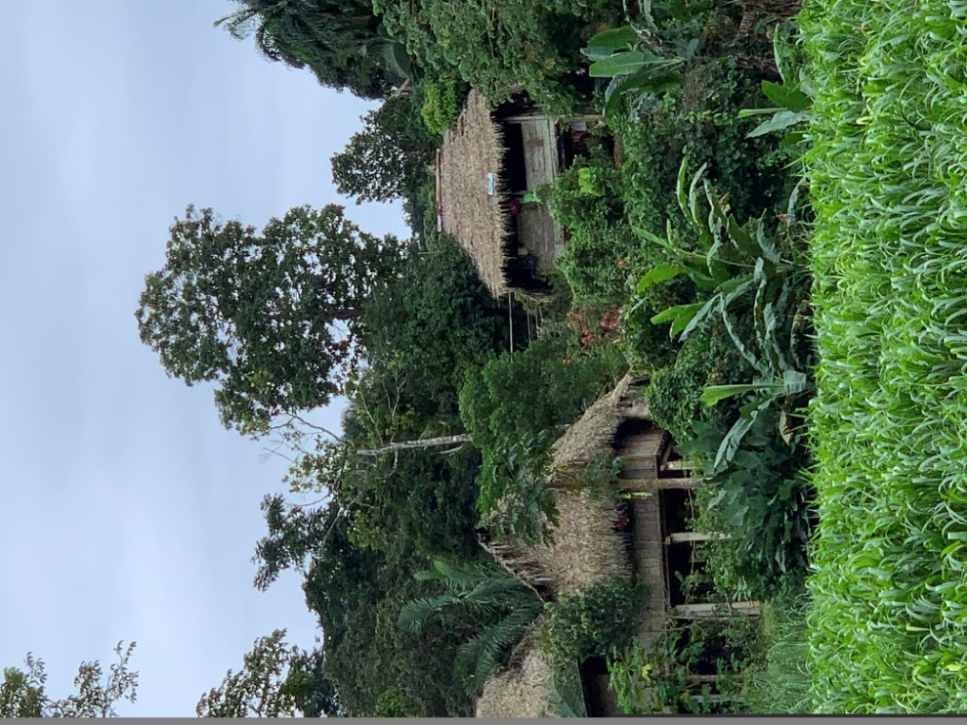
The Village
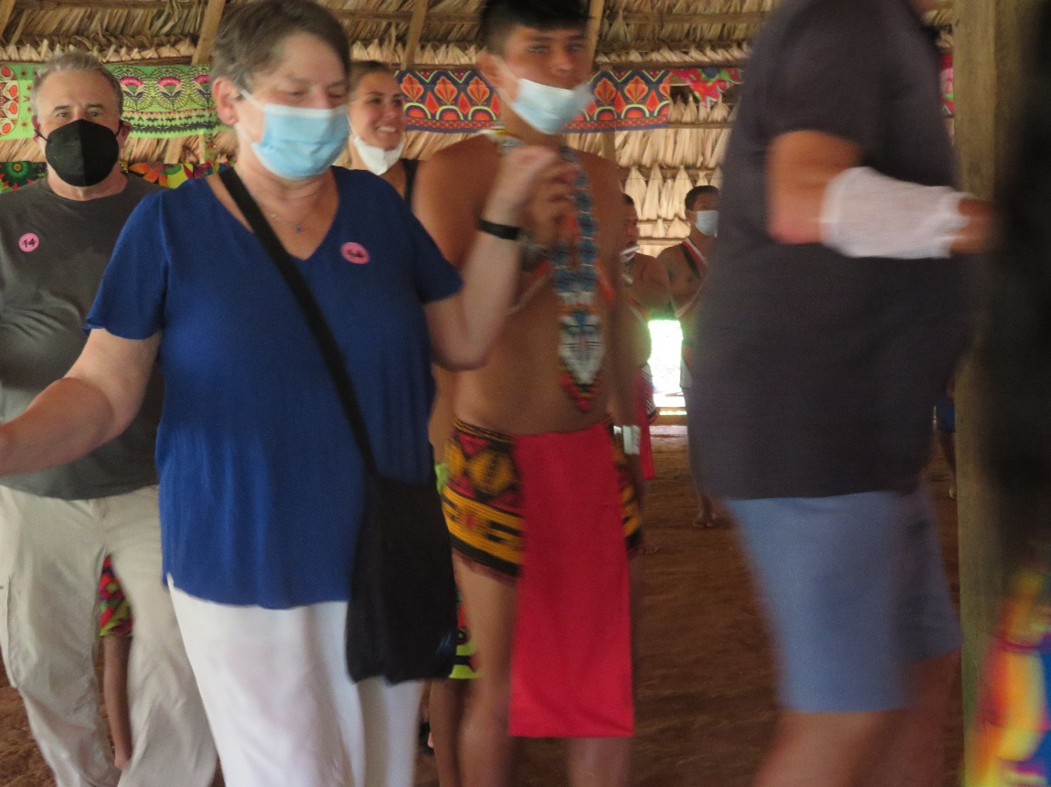
Rosemary Dancing with the Embera
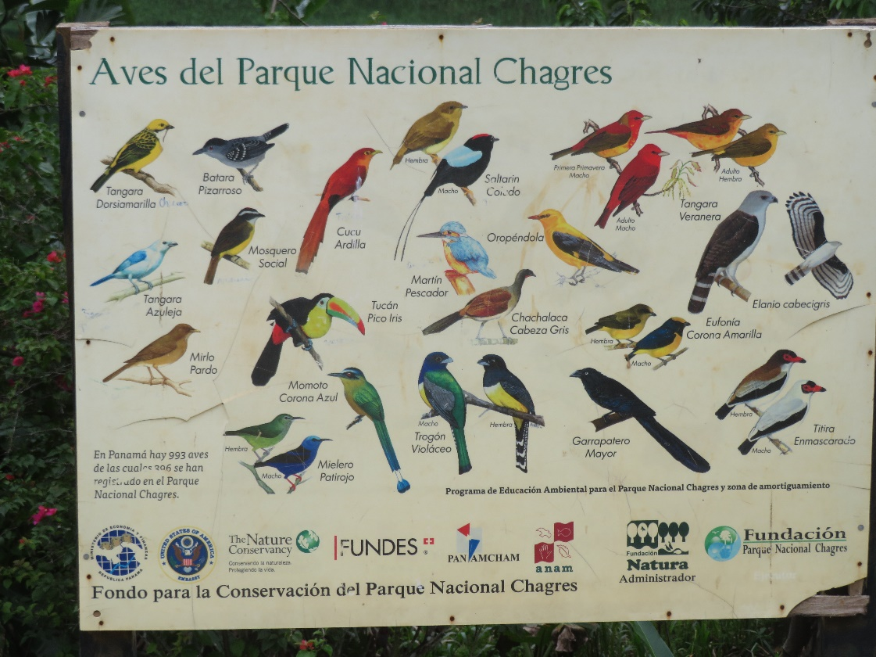
The Birds of the Park

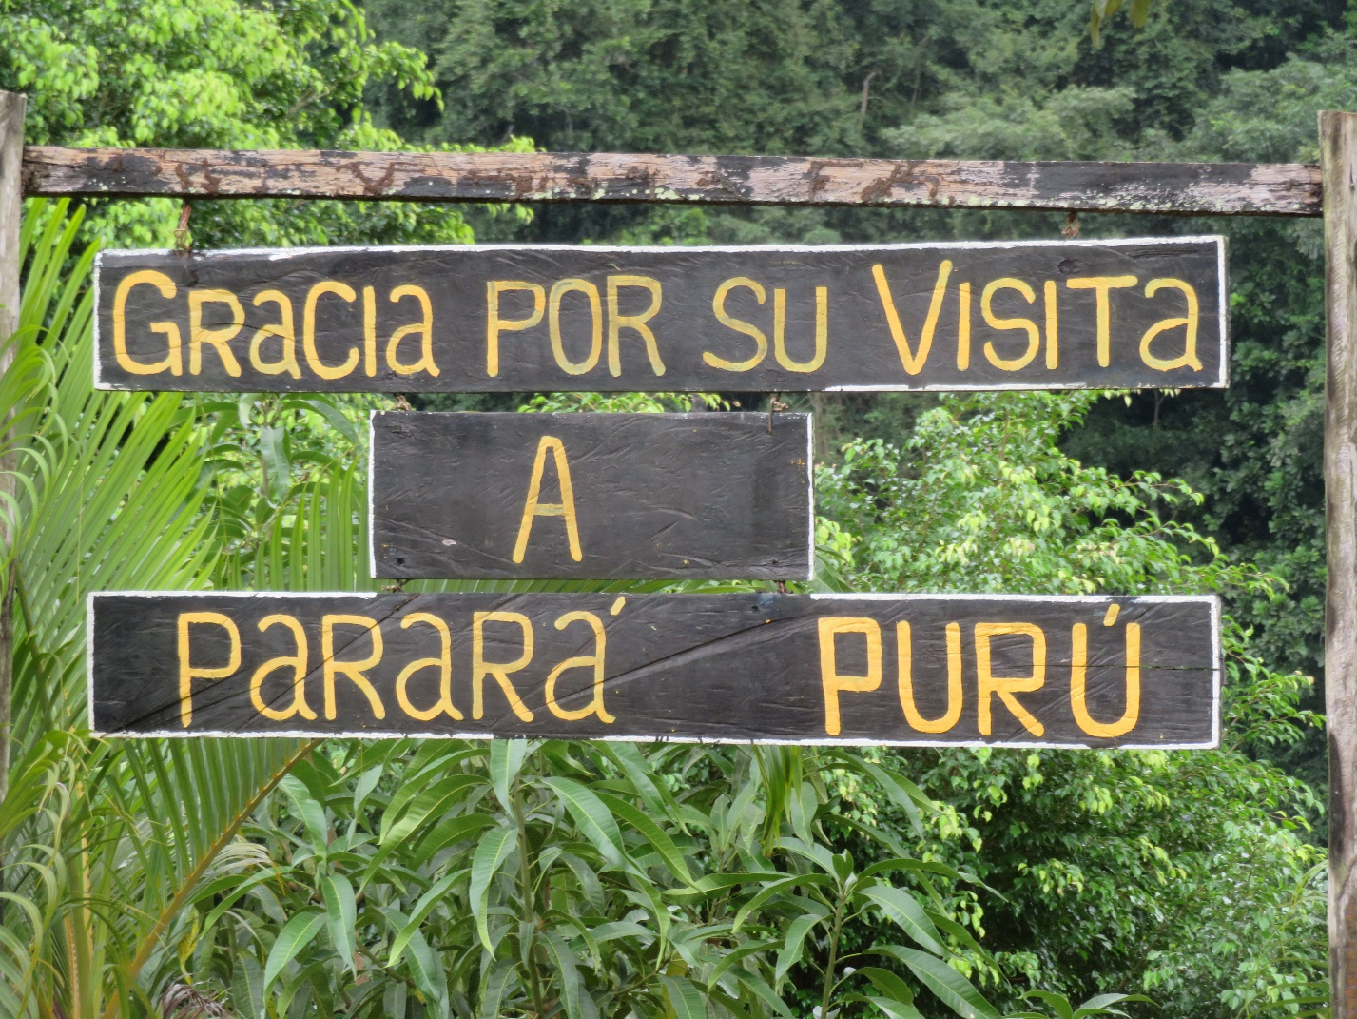

Thanks for your visit to our village

