Day 10 - Puntarenas, Costa Rica
Because we will be back in Costa Rica in a month, we decided against doing any excursions from the ship. We contented ourselves with walking along the shore for half an hour. Stay tuned for a detailed report on our Costa Rican travels.
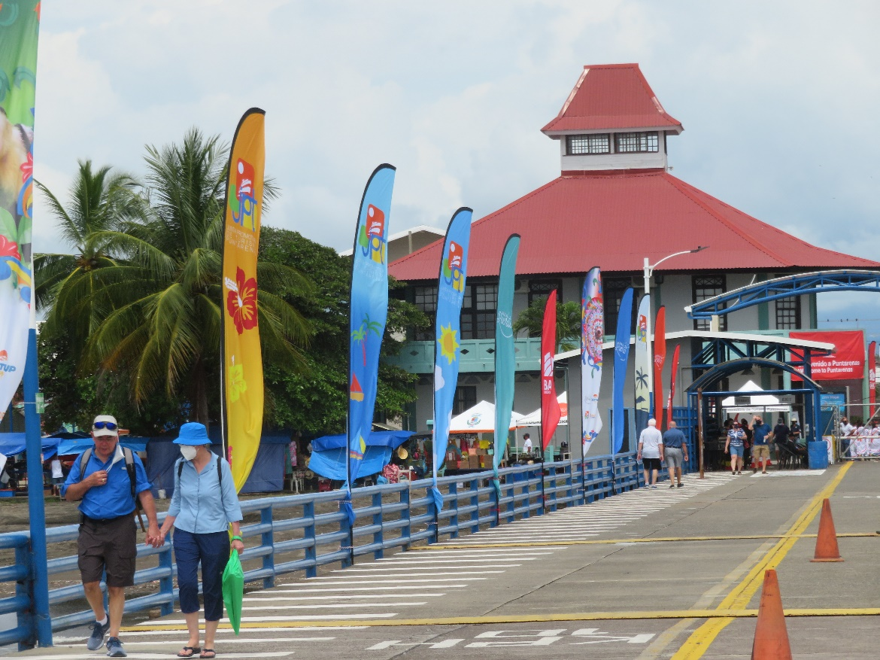
Walkway from Ship

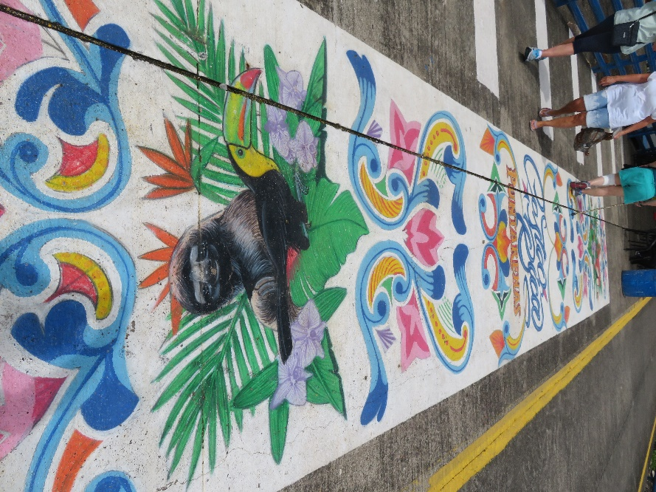
Walkway from Ship
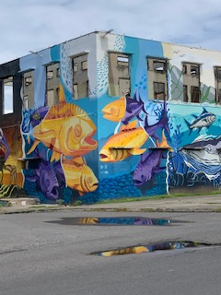
Aquarium Under Construction
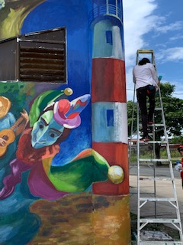
Museum Undergoing Refurbishment

