Day 8 - Antigua, Guatemala
One of the two ports in Guatemala, Puerto Quetzal sits on the Pacific Coast. Our principal reason for wanting to stop in Guatemala was for the excursion to Antigua, touted as “the best-preserved colonial city in Central America”. We had booked an excursion which was supposed to be just for transportation to the city, with time to wander on our own, but that was cancelled, so we re-booked what was described as a “panoramic” tour. (Tip: “Panoramic”, we discovered, means that the bus takes you through the countryside to the destination, then drives around the city, while the guide does his/her spiel. We recently learned that another term for this is a “bubble tour”.) What we had was an unauthorized hybrid, stopping at the Jade Museum for a somewhat informative talk about the mining and types of jade, and the obligatory shopping, then dropping us in the Plaza Mayor (main square) for half an hour. Having spent a lot of time in Mexico, we are accustomed to street vendors. Usually a smile and a polite “no, gracias” is enough to deter them. We have to say that we have never seen such aggressive vendors in all our travels. Maybe it’s a function of the pandemic cutting off their livelihood for over a year; I’ll be generous with that explanation. But they literally followed us around the Plaza, sticking like glue. Normally, mild-mannered Bob would politely brush them off, but he was so irritated that he confided that he was on the point of punching one of the men who wouldn’t take NO for an answer while he was trying to take photos. I was a bit more charitable, ultimately buying an inexpensive necklace. Carrying around a really cute baby is sure to increase sales.
After the build-up we had regarding the architecture, we left less than completely impressed. Back at the ship, we spoke with the Shore Excursion representative to give him our feedback. He took copious notes and thanked us, assuring us that the problems would be discussed with various groups – including the local mayor – to alleviate some of the problems. Later, after our stop at Cartagena, we went back and gave him a glowing report on that tour. This time he really thanked us for giving positive feedback, in the form of a $200 voucher at the art gallery – which we were happy to take advantage of. At this point, our daughter would (and did) pipe up: “What were you thinking? You don’t have enough wall space for the art you already have, and besides, you have no house!” She’s right, of course, but when something speaks strongly to you, you have to answer, or you will regret it. We know this from experience.
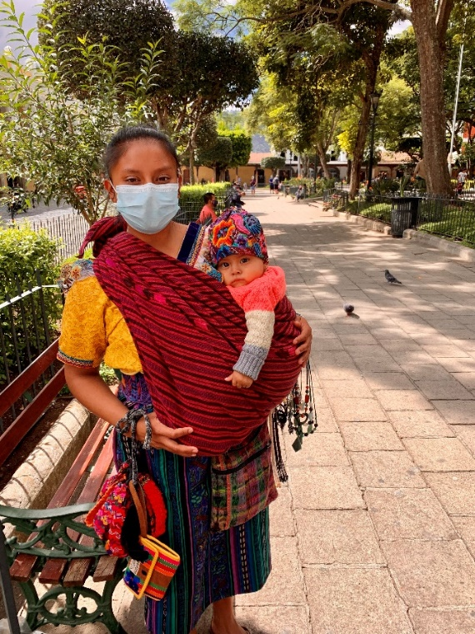
Mother and Child
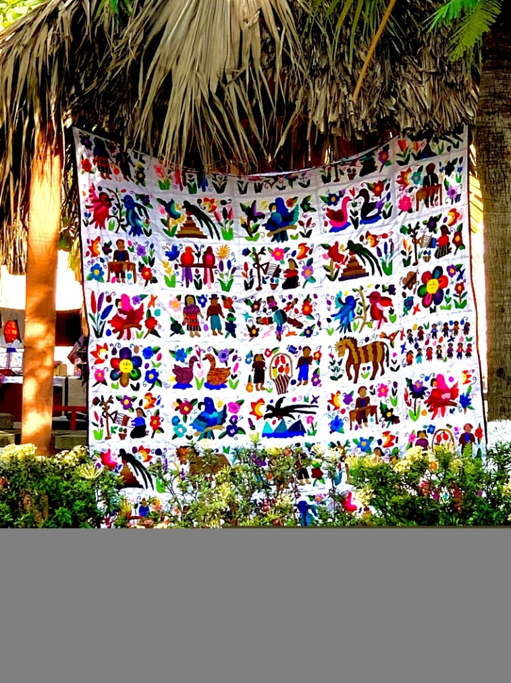
Typical Quilted Blanket
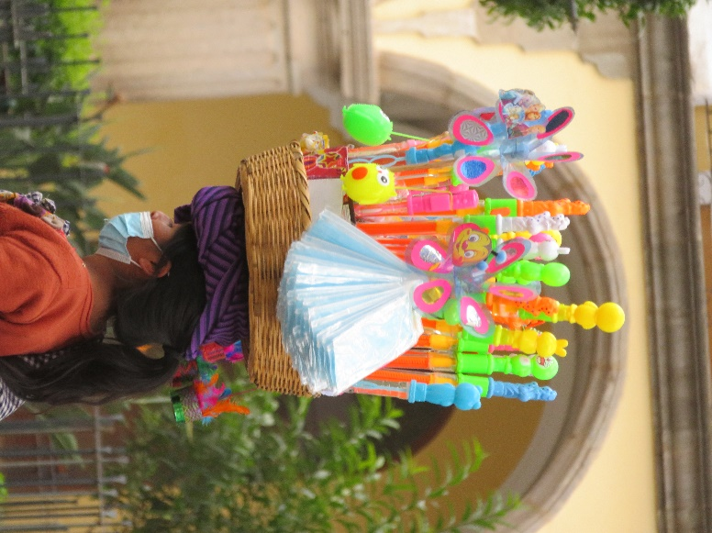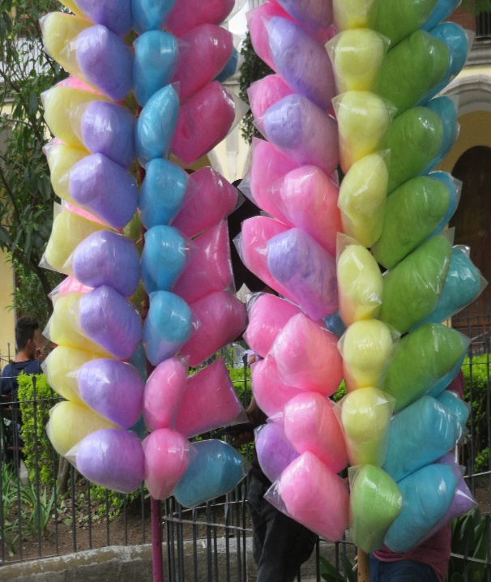
Vendors
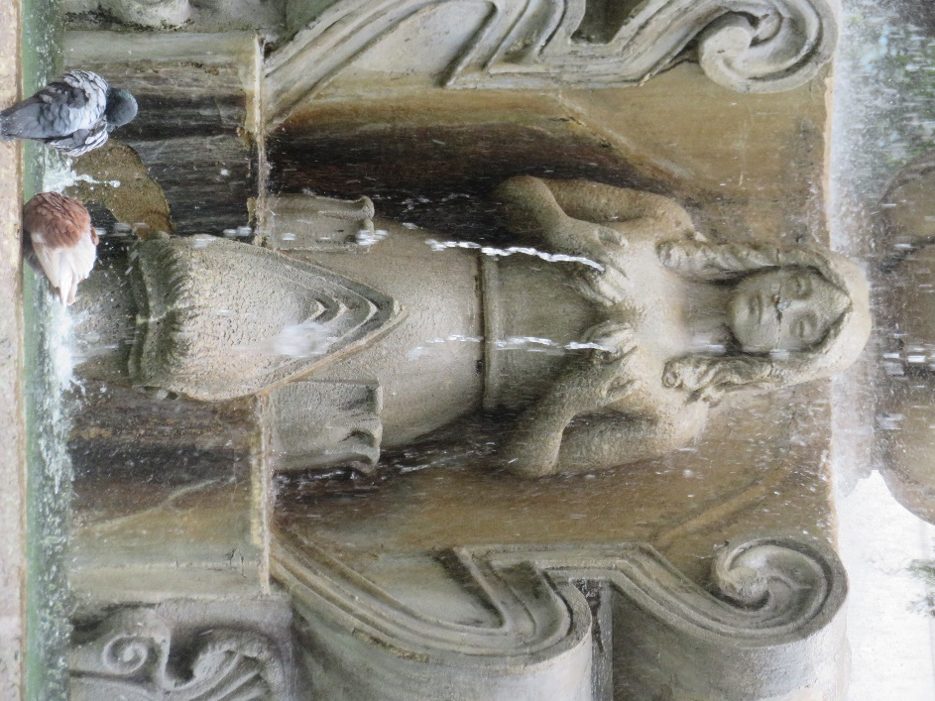
Fountain in Main Square
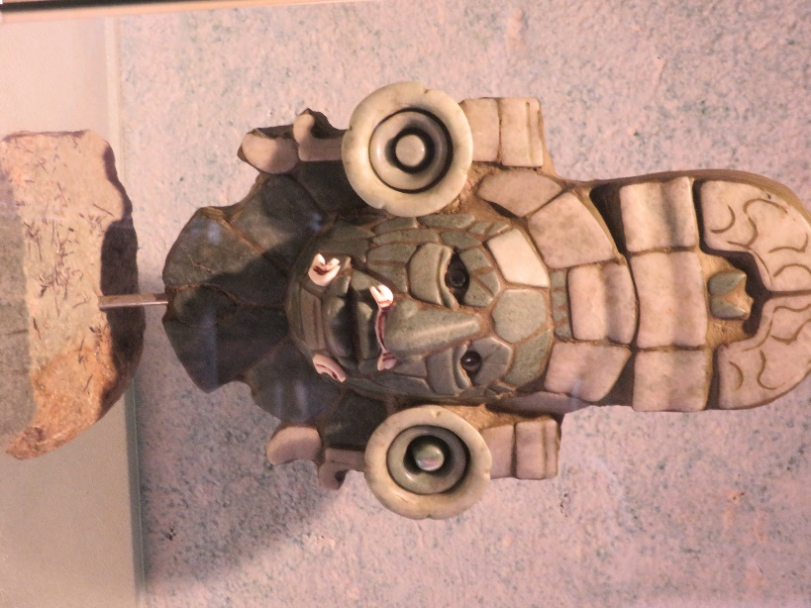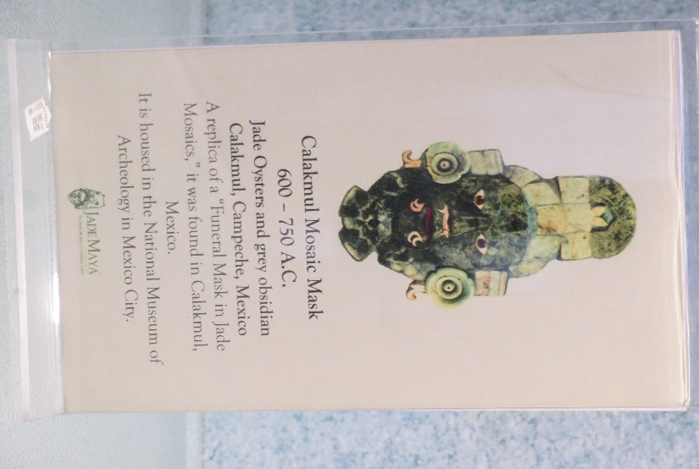
From the Jade Museum

